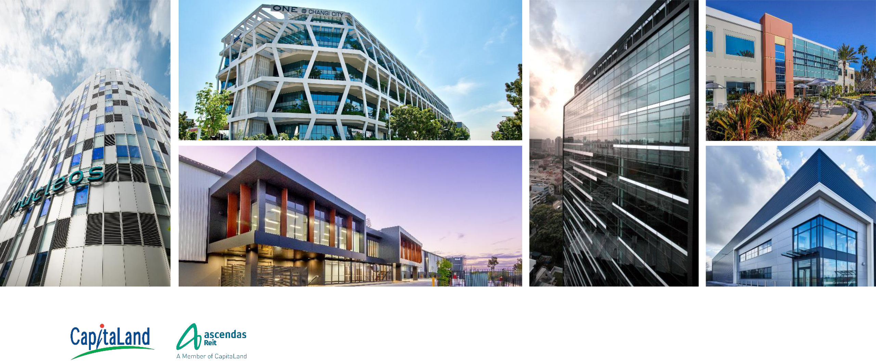

**ASCENDAS REIT**

FY2019 Financial Results Presentation

31 January 2020

_

**Disclaimers**

* **This material shall be read in conjunction with Ascendas Reit’s financial statements for the financial year ended 31 December 2019.**
* This presentation may contain forward-looking statements. Actual future performance, outcomes and results may differ materially from those expressed in forward-looking statements as a result of a number of risks, uncertainties and assumptions. Representative examples of these factors include (without limitation) general industry and economic conditions, interest rate trends, cost of capital and capital availability, availability of real estate properties, competition from other developments or companies, shifts in customer demands, shifts in expected levels of occupancy rate, property rental income, charge out collections, changes in operating expenses (including employee wages, benefits and training, property operating expenses), governmental and public policy changes and the continued availability of financing in the amounts and the terms necessary to support future business.
* You are cautioned not to place undue reliance on these forward-looking statements, which are based on the current view of management regarding future events. No representation or warranty expressed or implied is made as to, and no reliance should be placed on, the fairness, accuracy, completeness or correctness of the information or opinions contained in this presentation. Neither Ascendas Funds Management (S) Ltd (“Manager”) nor any of its affiliates, advisers or representatives shall have any liability whatsoever (in negligence or otherwise) for any loss howsoever arising, whether directly or indirectly, from any use, reliance or distribution of this presentation or its contents or otherwise arising in connection with this presentation.
* The past performance of Ascendas Real Estate Investment Trust (“Ascendas Reit”) is not indicative of future performance. The listing of the units in the Ascendas Reit (“Units”) on the Singapore Exchange Securities Trading Limited (the “SGX-ST”) does not guarantee a liquid market for the Units. The value of the Units and the income derived from them may fall as well as rise. Units are not obligations of, deposits in, or guaranteed by, the Manager. An investment in the Units is subject to investment risks, including the possible loss of the principal amount invested. Investors have no right to request that the Manager redeem or purchase their Units while the Units are listed on the SGX-ST. It is intended that holders of Units may only deal in their Units through trading on the SGX-ST.
* This presentation is for information only and does not constitute an invitation or offer to acquire, purchase or subscribe for the Units.

2

**Agenda**

|  |  |
| --- | --- |
| Key Highlights for FY2019 | 4 |
|  |  |
| Financial Performance | 6 |
|  |  |
| Investment Management | 11 |
|  |  |
| Capital Management | 21 |
|  |  |
| Asset Management | 28 |
|  |  |
| Portfolio Resilience | 47 |
|  |  |
| Market Outlook | 53 |
|  |  |

3

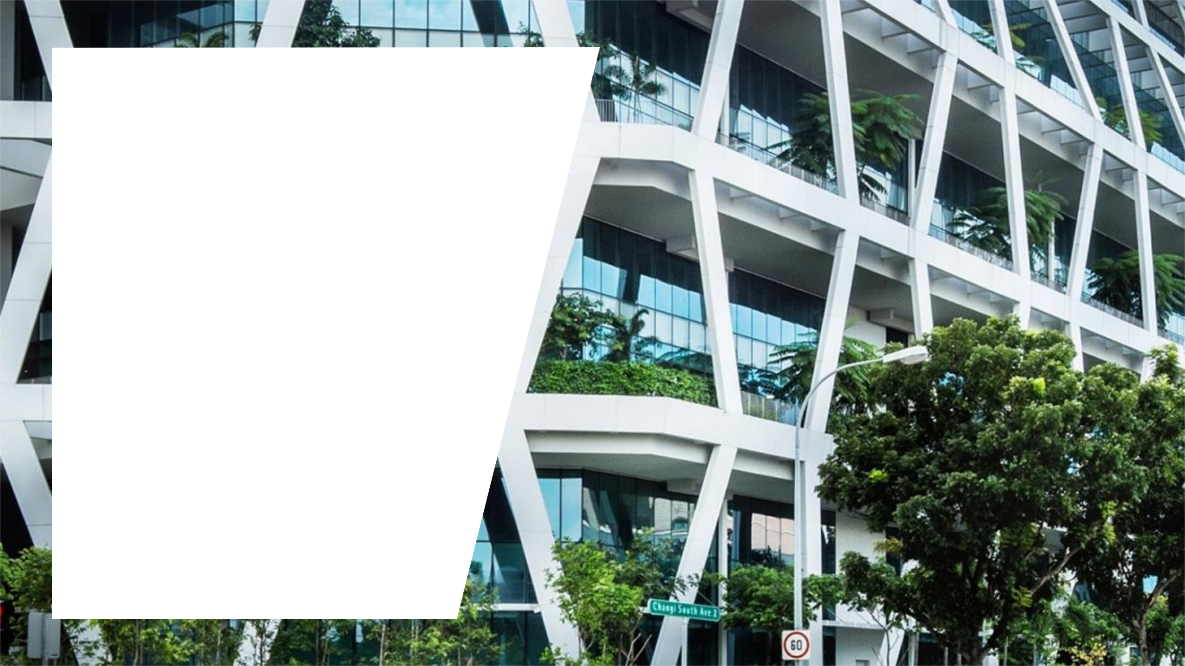

**Key Highlights for**

**FY2019**

ONE@Changi City, Singapore



**Key Highlights for FY2019 (April to Dec)\***

Distributable Income



**S$375.4 m**

***+5.2% y-o-y***

Mainly attributable to newly

acquired properties in UK, US and Singapore



Distribution per Unit

**11.490 cents**

***-3.3% y-o-y***

The Units issued under the

Dec 2019 Rights Issue are

entitled to the full

distribution of the Dec

2019 quarter



Total Assets



**S$13.9 b**

Acquired S$1.77b of

properties across the US, Singapore and Australia



|  |  |  |  |  |
| --- | --- | --- | --- | --- |
| Stable Portfolio | Positive Portfolio | Lower Aggregate | Stable Same-store |  |
| Occupancy | Rental Reversion# | Leverage to | Valuation |  |
| **90.9 %** | **+6.0%** | **35.1%** | **S$11.13 b** |  |
|  |  |  |
| As at 31 Dec 2019 |  | From 36.2% as at 30 Sep 2019 | (vs. S$11.10 b @ 31 Mar 2019) |  |

* Ascendas Reit has changed its financial year end from 31 Mar to 31 Dec. Therefore, the current financial year is a nine-month period from 1 Apr 2019 to 31 Dec 2019.

# Percentage change of the average gross rent over the lease period of the renewed leases against the preceding average gross rent from lease start date. Takes into account renewed 5 leases in multi-tenant buildings that were signed in FY2019 and average gross rents are weighted by area renewed.

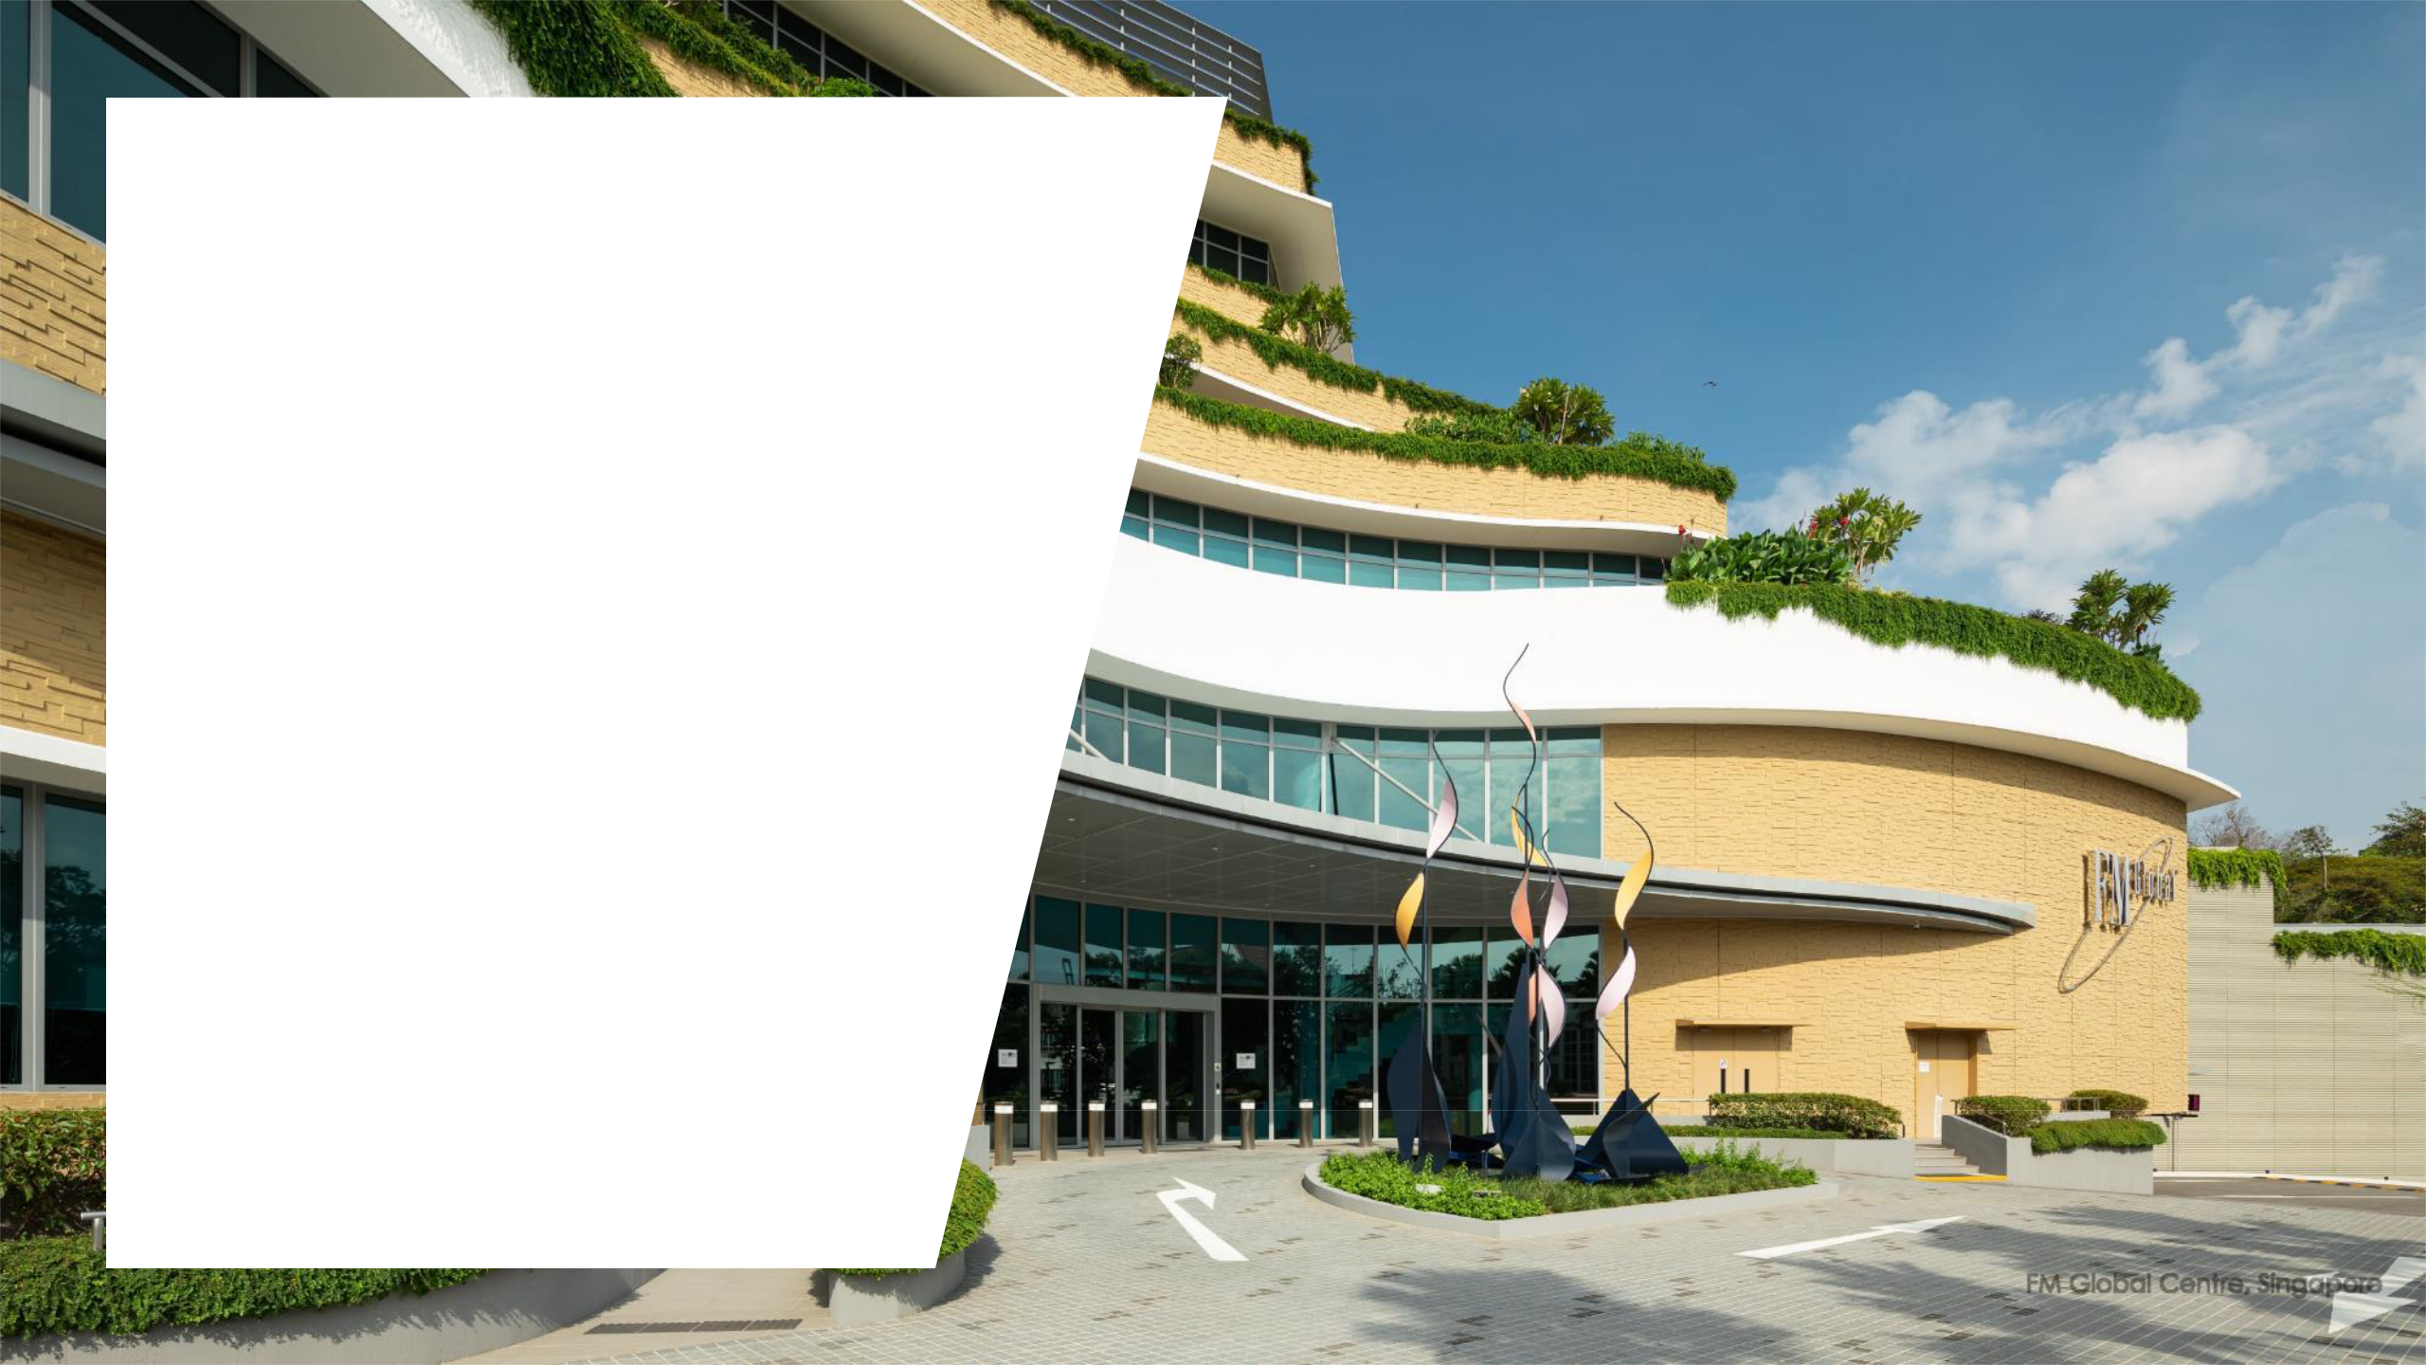

**Financial Performance**

FM Global Centre, Singapore

6

**3Q FY2019 vs 3Q FY18/19**

|  |  |  |  |  |  |
| --- | --- | --- | --- | --- | --- |
| **(S$’m)** | **3Q** | **3Q** | **Variance** |  |  |
| **FY2019** | **FY18/19** |  |  |
|  |  |  |  |
|  |  |  |  | Mainly attributable to: |  |
| **Gross revenue** | **239.7** | 226.4 | **+5.9%** | • Contributions from the US portfolio consisting of 28 business park properties and |  |
| two Singapore business park properties, which were acquired in Dec 2019 |  |
|  |  |  |  |  |

• Liquidated damages in relation to the pre-termination of a lease in Australia.

Mainly due to:

|  |  |  |  |  |  |  |
| --- | --- | --- | --- | --- | --- | --- |
|  |  |  |  | • | Effects of FRS 116 where land rent expense of $8.2 mil was recorded in |  |
| **Net property Income** | **182.3** | 168.0 | **+8.5%** |  | 3QFY18/19 but nil in 3QFY2019, offset by |  |
| • | Higher expenses from the new acquisitions made in Dec 2019, accrual of |  |
| **(NPI)** |  |
|  |  |  |  | maintenance costs for certain properties in Singapore in 3QFY2019 and lower |  |
|  |  |  |  |  | property tax expense arising from the retrospective downward revision in the |  |
|  |  |  |  |  | annual value of certain properties in 3Q FY18/19 |  |
|  |  |  |  |  | |  |
| **Total amount available** |  |  |  | • Higher distributable income is contributed by the increase in NPI, partially offset | |  |
| **126.9** | 124.3 | **+2.1%** |  | by lower rental guarantees/lease incentives (RG/LI) from the UK and Australia |  |
| **for distribution (DI)** |  | due to the expiry of certain RG/LI as well as higher interest expenses in |  |
|  |  |  |  |  |
|  |  |  |  |  | 3QFY2019. |  |
|  |  |  |  |  | |  |
|  |  |  |  | • DPU decreased 12.3% due to the enlarged number of Units in issue arising from | |  |
| **DPU (cents)** | **3.507** | 3.998 | **-12.3%** |  | the Rights Issue(1) |  |
| • | Includes taxable (3Q FY2019: 2.956 cents, 3Q FY18/19: 3.456 cents), tax exempt |  |
|  |  |  |  |  | (3Q FY2019: 0.130 cents, 3Q FY18/19: Nil) and capital (3Q FY2019: 0.421 cents, |  |
|  |  |  |  |  | 3Q FY18/19: 0.542 cents) distributions |  |
|  |  |  |  |  |  |  |
| **Applicable no. of units** | **3,618** | 3,109 | **+16.4%** |  |  |  |
| **(m)** |  |  |  |
|  |  |  |  |  |  |
|  |  |  |  |  |  |  |

Note: The Group had 200 properties as at 31 Dec 2019 and 171 properties as at 31 Dec 2018.

1. The Rights Issue was conducted to partially finance the acquisitions of 28 business park properties in the US and two business park properties in Singapore. Although the acquisitions were completed and these properties started contributing income to Ascendas Reit on 11 December, the Rights Units that were issued on 6 December 2019 rank *pari passu* in all respects with the Units in issue before the Rights Issue, including the right to the distributions for the period from

|  |  |
| --- | --- |
| 1 October 2019 to 31 December 2019. | 7 |

**3Q FY2019 vs 2Q FY2019**

|  |  |  |  |  |
| --- | --- | --- | --- | --- |
| **(S$’m)** | **3Q** | **2Q** | **Variance** |  |
| **FY2019** | **FY2019** |  |
|  |  |  |
|  |  |  |  |  |
| **Gross revenue** | **239.7** | **229.6** | **+4.4%** |  |
|  |  |  |  |  |

* Increase in gross revenue is largely due to the acquisitions of 28 business park properties in the US and two business park properties in Singapore.

|  |  |  |  |  |  |
| --- | --- | --- | --- | --- | --- |
| **Net property income** | **182.3** | **177.9** | **+2.5%** | • Higher net property income was mainly contributed by the acquisitions |  |
| **(NPI)** | made in Dec 19, partially offset by higher accrued operating expenses in 3Q |  |
|  |  |  | FY2019. |  |
|  |  |  |  |  |  |
| **Total amount available** | **126.9** | **123.8** | **+2.5%** | • Distributable income increased in tandem with the increase in NPI |  |
| **for distribution (DI)** |  |
|  |  |  |  |  |

* DPU decreased 11.8% due to the enlarged number of Units in issue arising from the Rights Issue(1)

|  |  |  |  |  |  |  |  |
| --- | --- | --- | --- | --- | --- | --- | --- |
| **DPU (cents)** | **3.507** | **3.978** | **-11.8%** •Includes taxable (3Q FY2019: 2.956 | | cents, 2Q | FY2019: 3.436 cents), tax |  |
|  |  |  |  | exempt (3Q FY2019: 0.130 cents, 2Q | FY2019: Nil) | and capital (3Q FY2019: |  |
|  |  |  |  | 0.421 cents, 2Q FY2019: 0.542cents) distributions | |  |  |
|  |  |  |  |  |  |  |  |
| **Applicable no. of units** | **3,618** | **3,112** | **+16.3%** |  |  |  |  |
| **(m)** |  |  |  |  |
|  |  |  |  |  |  |  |
|  |  |  |  |  |  |  |  |

Note: The Group has 200 properties as at 31 Dec 2019 and 170 properties as at 30 Sep 2019.

1. The Rights Issue was conducted to partially finance the acquisitions of 28 business park properties in the US and two business park properties in Singapore. Although the acquisitions were completed and these properties started contributing income to Ascendas Reit on 11 December, the Rights Units that were issued on 6 December 2019 rank *pari passu* in all respects with the Units in issue before the Rights Issue, including the right to the distributions for the period

|  |  |
| --- | --- |
| from 1 October 2019 to 31 December 2019. | 8 |

**Nine Months Period Comparison (April to December)**

|  |  |  |  |  |  |  |
| --- | --- | --- | --- | --- | --- | --- |
| **(S$’m)** | **9-months** | **9-months** |  |  |  |  |
| **ended 31** | **ended 31** | **Variance** |  |  |  |
|  | **Dec 2019** | **Dec 2018** |  |  |  |  |
|  |  |  |  | Mainly attributable to: | |  |
|  |  |  |  | • Nine months contribution in FY2019 from the 2 UK Portfolios consisting of 38 | |  |
| **Gross revenue** | **699.1** | 661.1 | **+5.7%** |  | logistics properties acquired in Aug and Oct 2018 |  |
| • | Contributions from the US portfolio consisting of 28 business park properties and |  |
|  |  |  |  |  |
|  |  |  |  |  | two Singapore business park properties, which were acquired in Dec 2019, |  |
|  |  |  |  | • Liquidated damages in relation to the pre-termination of a lease in Australia. | |  |
| **Net property Income** | **537.7** | 486.1 | **+10.6%** | • Excluding the effects of FRS 116 (S$24.6 mil), NPI would have increased by 5.6% | |  |
| **(NPI)** |  | that is in tandem with the increase in gross revenue. |  |
|  |  |  |  |  |
|  |  |  |  |  | |  |
| **Total amount available** | **375.4** | 356.7 | **+5.2%** | • Higher distributable income corresponds with the increase in NPI excluding the | |  |
| **for distribution (DI)** |  | effects for FRS116. |  |
|  |  |  |  |  |
|  |  |  |  |  | |  |
|  |  |  |  | • DPU decreased by 3.3% despite the increase in DI after taking into consideration | |  |
| **DPU (cents)** | **11.490** | 11.887 | **-3.3%** |  | the enlarged number of Units in issue arising from the Rights Issue(1). |  |
| • | Includes taxable (9M FY2019: 9.887 cents, 9M FY18/19: 10.640 cents), tax exempt |  |
|  |  |  |  |  | (9M FY2019: 0.130, 9M FY18/19: Nil) and capital (9M FY2019: 1.473 cents, 9M |  |
|  |  |  |  |  | FY18/19: 1.247 cents) distributions |  |
| **Applicable no. of units** | **3,267** | **3,000** | **+8.9%** |  |  |  |
| **(m)** |  |  |  |
|  |  |  |  |  |  |
|  |  |  |  |  |  |  |

Note: The Group had 200 properties as at 31 Dec 2019 and 171 properties as at 31 Dec 2018.

1. The Rights Issue was conducted to partially finance the acquisitions of 28 business park properties in the US and two business park properties in Singapore. Although the acquisitions were completed and these properties started contributing income to Ascendas Reit on 11 December, the Rights Units that were issued on 6 December 2019 rank *pari passu* in all respects with the Units in issue before the Rights Issue, including the right to the distributions for the period from 1 October 2019 to 31 December 2019.

9

**Distribution Details**

|  |  |  |  |
| --- | --- | --- | --- |
| **Distribution Period** | | **DPU (Singapore cents)** |  |
|  | |  |  |
|  |  |  |  |
| **1 October 2019 to 31 December 2019 \*** |  | **3.507** |  |
|  |  |  |  |
|  |  |  |  |
| **Distribution timetable** | |  |  |
|  |  |  |  |
|  |  | 6 February 2020 (Thursday) |  |
| **Last day of trading on “cum” basis** | |  |
|  |  | 7 February 2020 (Friday), 9.00 am |  |
|  |  |  |
| **Ex-distribution date** | |  |
|  |  |  |  |
|  |  |  |  |
| **Books closure date** | | **10 February 2020 (Monday), 5.00 pm** |  |
|  |  | 4 March 2020 (Wednesday) |  |
|  |  |  |
| **Distribution payment date** | |  |
|  |  |  |  |

* Due to Ascendas Reit’s change in financial year from 31 March to 31 December, this distribution payment is for the 3-month period ended 31 December 2019. Thereafter, the regular distributions shall be made on a semi-annual basis for every 6-month period ending 30 June and 31 December each year.

10



**Investment**

**Management**

15378 Avenue of Science

San Diego, United States

**Investment Highlights**

* Acquired S$1.77 b worth of properties in US (S$1,285.3 m), Singapore (S$380.0 m) and Australia (S$104.4 m)

|  |  |  |  |  |  |
| --- | --- | --- | --- | --- | --- |
|  |  |  | **Purchase** |  |  |
| **FY 2019 (Apr to Dec 2019)** | **City / Country** | **Sub-segment** | **Consideration/** | **Completion** |  |
| **Land & Development** | **Date** |  |
|  |  |  |  |
|  |  |  | **cost (S$m)** |  |  |
|  |  |  |  |  |  |
| **Acquisitions** |  |  | **1,769.7** |  |  |
|  |  |  |  |  |  |
|  | San Diego, |  |  |  |  |
| US Portfolio (28 properties) | Raleigh, Portland | Business Park | 1,285.3 | 11 Dec 2019 |  |
|  | United States |  |  |  |  |
|  |  |  |  |  |  |
| Nucleos | Singapore | Business Park | 289.0 | 11 Dec 2019 |  |
| FM Global Centre | Singapore | Business Park | 91.0 | 11 Dec 2019 |  |
| 254 Wellington Road | Melbourne, | Suburban Office | 104.4 | 2Q FY2020 |  |
| Australia | (estimated) |  |
|  |  |  |  |
|  |  |  |  |  |  |

12

**Investment Highlights**

* Completed asset enhancement at ONE@Changi City for S$4.5 m and divestment of 8 Loyang Way 1 for $27.0 m
* Two divestments expected in 1Q 2020 with total sale price of S$105.0 m

|  |  |  |  |  |  |
| --- | --- | --- | --- | --- | --- |
| **FY 2019 (Apr to Dec 2019)** | **Country** | **Sub-segment** | **Total Cost/Sale Price** | **Completion** |  |
| **(S$m)** | **Date** |  |
|  |  |  |  |
|  |  |  |  |  |  |
| **Asset Enhancement Initiative** |  |  | **4.5** |  |  |
|  |  |  |  |  |  |
| ONE@Changi City | Singapore | Business Park | 4.5 | Oct 2019 |  |
|  |  |  |  |  |  |
| **Divestment** |  |  | **27.0** |  |  |
|  |  |  |  |  |  |
| 8 Loyang Way 1 | Singapore | Light industrial | 27.0 | 18 Sep 2019 |  |
|  |  |  |  |  |  |
|  |  |  |  |  |  |
| **1Q FY2020** | **Country** | **Sub-segment** | **Sale Price (S$m)** | **Completion** |  |
| **Date** |  |
|  |  |  |  |  |
|  |  |  |  |  |  |
| **Divestments** |  |  | **105.0** |  |  |
|  |  |  |  |  |  |
| Wisma Gulab | Singapore | Hi-Specs | 88.0 | 23 Jan 2020 |  |
|  |  |  |  |  |  |
| 202 Kallang Bahru | Singapore | Light industrial | 17.0 | 1Q FY2020 |  |
| (estimated) |  |
|  |  |  |  |  |
|  |  |  |  |  |  |
|  |  |  |  | 13 |  |

**Acquisition: 28 Business Park Properties, United States**

|  |  |  |
| --- | --- | --- |
| Purchase Consideration | US$937.6 m (S$1,285.3 m) |  |
| Acquisition Fee(1), Stamp Duty and | US$17.05 m (S$23.3 m) |  |
| Other Transaction Costs |  |
|  |  |
| Total Acquisition Cost | US$954.6 m (S$1,308.6 m) |  |
|  |  |  |
| Vendor | Perpetual (Asia) Limited (as trustee |  |
| of Ascendas US REIT) |  |
|  |  |
| Valuation (as at acquisition) | JLL: US$942.3 m (S$1,291.7m) |  |
| Newmark Knight Frank: US$961.5 m (S$1,318.0m) |  |
|  |  |
|  |  |  |
| Land Area | 994,065 sqm |  |
| Land Tenure | Freehold |  |
| Net Lettable Area (as at acquisition) | 310,102 sqm |  |
| Occupancy Rate (as at acquisition) | 93.7% |  |
|  |  |  |
| Weighted Average Lease Expiry | 4.2 years |  |
| (as at acquisition) |  |
|  |  |
|  | CareFusion Manufacturing, Teleflex Medical, TD |  |
| Key Tenants | Ameritrade Services, Northrop Grumman |  |
|  | Systems |  |
| Initial Net Property Income Yield | 6.4% (6.3% post-transaction cost) |  |
| Completion Date | 11 Dec 2019 |  |
|  |  |  |

Note: All S$ amount are based on exchange rate of US$1.00: S$1.3708 as at 30 Sep 2019 (per acquisition announcement).

1. In accordance to Ascendas Reit’s Trust Deed, the Manager is entitled to an acquisition fee of 1.0% of the purchase consideration.

|  |  |  |
| --- | --- | --- |
| San Diego | Raleigh | Portland |

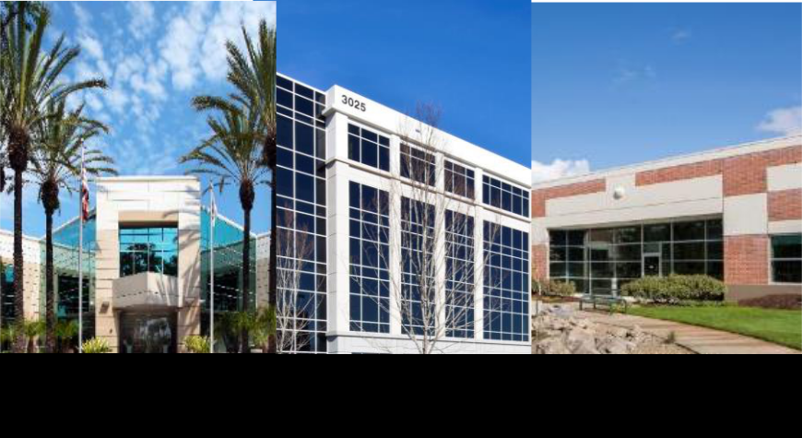

**28 Business Park Properties, US**

**The Portfolio**:

* 28 business park properties located in the US tech-cities of San Diego, Raleigh and Portland.

**Well-Located**:

* Properties are in close proximity to renowned universities and leading corporations
* San Diego is the second largest city in California and a key hub for Wireless Tech, Life Science and Defence industries.
* Raleigh is the capital of North Carolina and a key technology hub on the east coast. The Research Triangle is the largest research park in the US.
* Portland is the largest city in Oregon and known as the Silicon Forest and Athletic Performance Shoe Capital of

|  |  |
| --- | --- |
| the World. | 14 |

**Acquisition: Nucleos, Singapore**

|  |  |  |
| --- | --- | --- |
| Purchase Consideration | S$289.0 m |  |
| Acquisition Fee(1), Stamp Duty and Other | S$13.0 m |  |
| Transaction Costs |  |
|  |  |
| Total Acquisition Cost | S$302.0m |  |
|  |  |  |
| Vendor | Ascendas Venture Pte. Ltd |  |
| Valuation (as at acquisition) | CBRE: S$303.0 m |  |
| Colliers: S$300.0 m |  |
|  |  |
| Land Area | 9,621 sqm |  |
|  |  |  |
| Land Tenure | 52 years |  |
| Net Lettable Area (as at acquisition) | 38,149 sqm |  |
| Occupancy Rate (as at acquisition) | 92.9% |  |
| Weighted Average Lease Expiry | 2.1 years |  |
| (as at acquisition)(1) |  |
|  |  |
| Key Tenants | DuPont, Takeda |  |
|  |  |  |
| Initial Net Property Income Yield | 7.0% (6.7% post-transaction cost) |  |
| Completion Date | 11 Dec 2019 |  |
|  |  |  |

1. In accordance to Ascendas Reit’s Trust Deed, the Manager is entitled to an acquisition fee of 1.0% of the purchase consideration.

Nucleos, Singapore

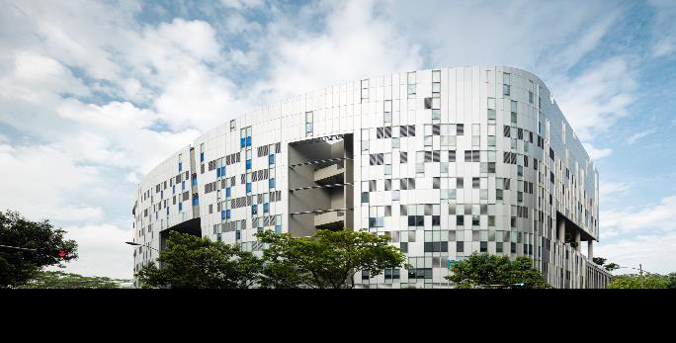

**The Property**:

* A seven-storey twin-tower biomedical research facility

**Well-Located**:

* Located at Biopolis, within the one-north business park
* About 10 minutes walking distance to one-north MRT station and Buona Vista MRT station, and is a few minutes’ drive to Ayer Rajah Expressway

15

**Acquisition: FM Global Centre, Singapore**

|  |  |  |
| --- | --- | --- |
| Purchase Consideration | S$91.0 m |  |
| Acquisition Fee(1), Stamp Duty and Other | S$4.1 m |  |
| Transaction Costs |  |
|  |  |
| Total Acquisition Cost | S$95.1 m |  |
| Vendor | Singapore Science Park Ltd |  |
|  |  |  |
| Valuation (as at acquisition) | CBRE: S$94.1 m |  |
| Colliers: S$92.0 m |  |
|  |  |
| Land Area | 9,678 sqm |  |
| Land Tenure | 73 years |  |
| Net Lettable Area | 11,613 sqm |  |
| Occupancy Rate (as at acquisition) | 100% |  |
|  |  |  |
| Weighted Average Lease Expiry | > 25 years |  |
| (as at acquisition) |  |
|  |  |
| Key Tenants | FM Global (100%) |  |
| Initial Net Property Income Yield | 5.7% (5.4% post-transaction cost) |  |
| Completion Date | 11 Dec 2019 |  |
|  |  |  |

1. In accordance to Ascendas Reit’s Trust Deed, the Manager is entitled to an acquisition fee of 1.0% of the purchase consideration.

FM Global Centre, Singapore

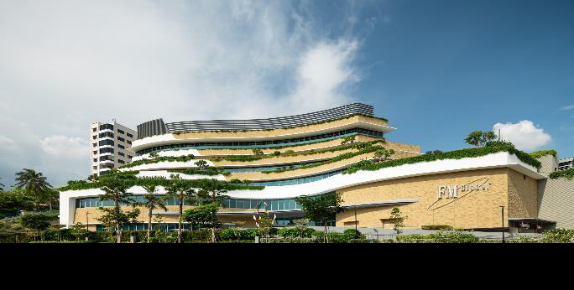

**The Property**:

* A six-storey built-to-suit business park development

**Well-Located**:

* Strategically located along Pasir Panjang Road, at the gateway of Singapore Science Park 2
* Within three minutes walking distance to Haw Par Villa MRT station, which serves the Circle line.
* Close proximity to West Coast Highway and a 15-minute drive to Ayer Rajah Expressway

16

**Acquisition: 254 Wellington Road, Melbourne, Australia**

|  |  |
| --- | --- |
| Land and Development Costs (1)(2) | A$110.9 million (S$104.4 million) |
| Acquisition Fee(3) , Stamp duty and Other | A$1.3 million (S$1.2 million) |
| Transaction Costs |  |
| Total Acquisition Cost | A$112.2 million (S$105.6 million) |
| Vendor | ESR FPA (Wellington Road) Pty |
|  | Limited |
| “As if Complete” Valuation (4) | A$110.9 million (S$104.4 million) |
| Land Area | 11,113 sqm |
| Land Tenure | Freehold |
| Net Lettable Area | 17,507 sqm |
| Occupancy Rate (upon completion)(5) | 100% |
| Key Tenants | Nissan |
| Initial Net Property Income Yield | 5.8% (5.7% post cost) |
| Estimated Practical Completion | 2Q FY2020 |
|  |  |

1. All S$ amounts are based on exchange rate of A$1.00000: S$0.94121 as at 30 Sep 2019
2. Includes incentives to be reimbursed by the Vendor.
3. In accordance to Ascendas Reit’s Trust Deed, the Manager is entitled to an acquisition fee of 1.0% of the purchase consideration (includes land and development cost) of the property.
4. The valuation dated 1 Aug 2019 was commissioned by the Manager and The Trust Company (Australia) Limited, in its capacity as trustee of Ascendas Business Park Trust No. 2, and was carried out by Urbis Valuations Pty Ltd , using the capitalisation method and discounted cashflow methods.
5. Physical occupancy is 65.2% (space pre-committed to Nissan). From practical completion date, the Vendor will provide a 3-year rental guarantee for any remaining vacant space.

Artist’s Illustration of 254 Wellington Road, Australia

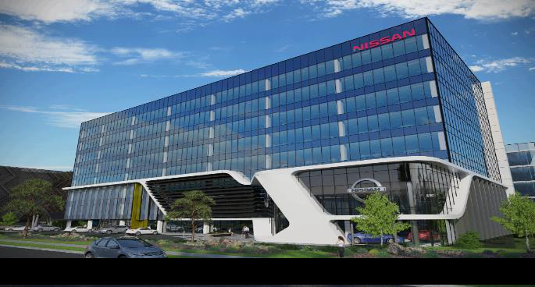

* Located 21km south east of the Melbourne CBD. Well located in one of Australia’s most important innovation precincts, the Monash Technology Precinct houses prestigious research organisations and high-technology industries.
* The 8-level state-of-the-art office with 17,705 sqm net lettable area; accorded with 5-star NABERS energy rating and 5 Star Green Star Design.
* Nissan will lease 65.2% of the space and the property will serve as its head office and training centre with emphasis on electric vehicles.

17

**Asset Enhancement Initiative Completed:**

**ONE@Changi City, Singapore**

|  |  |  |
| --- | --- | --- |
|  | Completed AEI works include a new lounge and |  |
|  | discussion area at the main lift lobby. |  |
|  | Enhancement works were also carried out at the |  |
| Description | general driveway and passenger pick up/drop- |  |
| off area which includes a new ceiling design, |  |
|  |  |
|  | digital feature wall and façade glass. The |  |
|  | driveway was also widened to improve traffic |  |
|  | movement. |  |
| Property Segment | Business & Science Park |  |
|  |  |  |
| Net Lettable Area | 61,297 sqm |  |
| Occupancy (as at 31 Dec 2019) | 92.7% |  |
| Cost | S$4.5m |  |
| Completion Date | Oct 2019 |  |
|  |  |  |

Main Lobby and Concierge counters

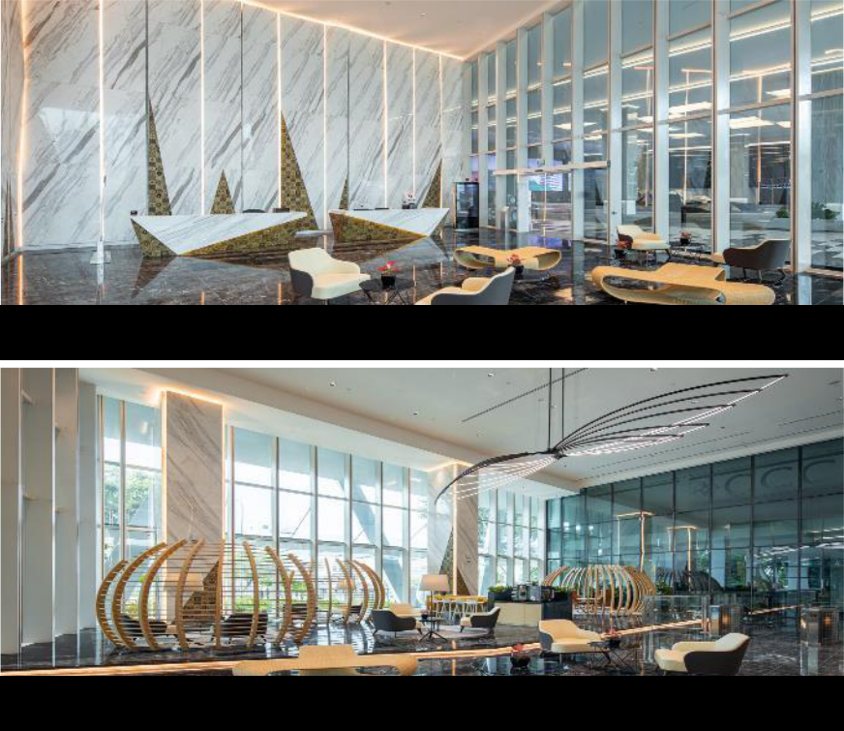

Lounge and Discussion area

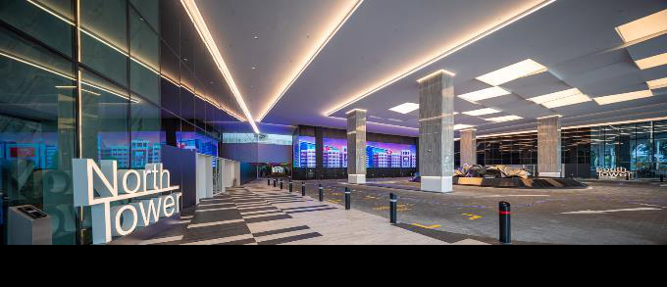

General driveway & Passenger pick-up/drop-off point

18

**1Q FY2020 Divestment: Wisma Gulab, Singapore**

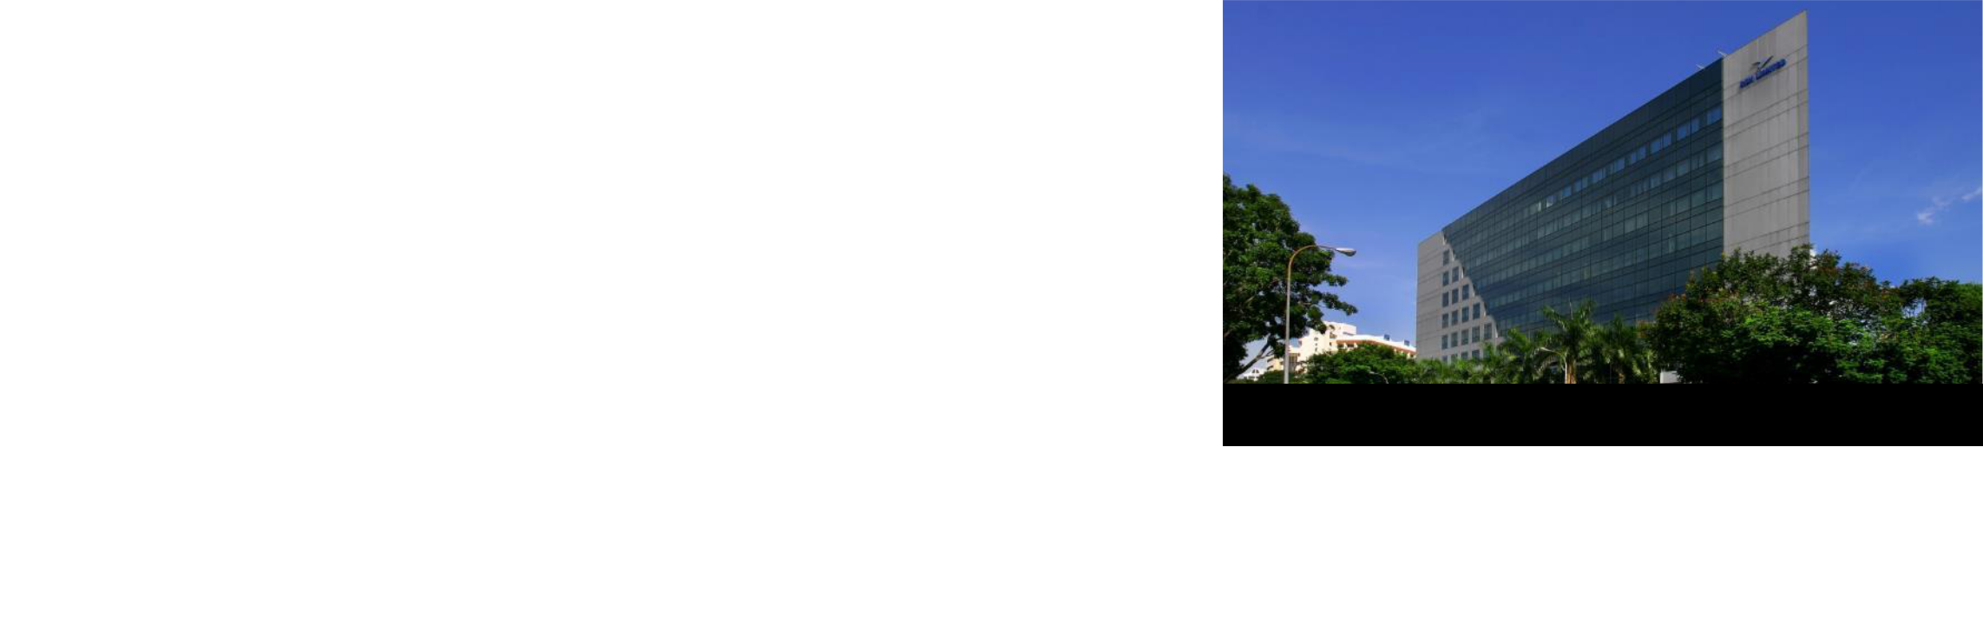

|  |  |  |
| --- | --- | --- |
|  | 9-storey industrial building with offices, |  |
| Description | showrooms, recreation room and a |  |
|  | basement carpark |  |
| Remaining Land Tenure | Freehold |  |
| (at point of sale) |  |
|  |  |
|  |  |  |
| Net Lettable Area | 11,821 sqm |  |
| Acquisition Year / Purchase Price | 2004/ S$55.7 m |  |
| Book Value/Valuation(1) (as at 31 Dec | S$83.4 m |  |
| 2019) |  |
|  |  |
|  |  |  |
| Sales Price(2) | S$88.0 m |  |
| Pro-forma (FY2019) NPI Impact | -S$3.6m |  |
| Buyer | Heap Seng Group Pte Ltd |  |
|  |  |  |
| Completion Date | 23 Jan 2020 |  |
|  |  |  |

1. The valuation was commissioned by the Manager and the Trustee, and was carried out by Knight Frank Pte Ltd using the capitalisation approach and discounted cash flow approach.
2. In accordance to Ascendas Reit’s Trust Deed, the Manager is entitled to a divestment fee of 0.5% of the sale price of the properties.

Wisma Gulab, Singapore

**The Property**:

* Wisma Gulab is a 9-storey high-specifications industrial building with offices, showrooms, recreation room and a basement carpark

**Location**:

* It is located at the corner of Genting Road and Macpherson Road, and accessible to major expressways like PIE and CTE.

19

**1Q FY2020 Divestment: 202 Kallang Bahru, Singapore**

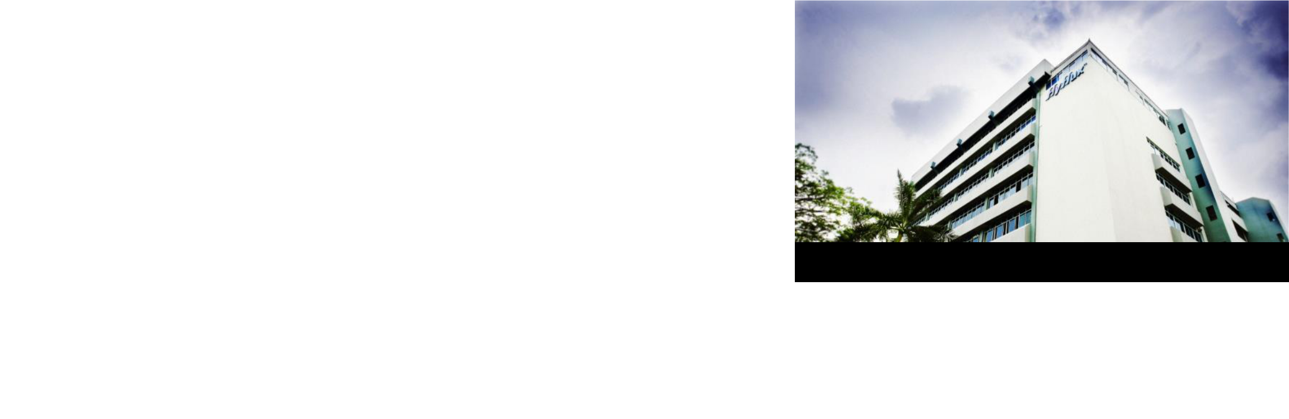

|  |  |  |
| --- | --- | --- |
| Description | 8-storey light industrial building with |  |
| ancillary office, auditorium and canteen |  |
|  |  |
| Remaining Land Tenure | 21 years |  |
| (at point of sale) |  |
|  |  |
|  |  |  |
| Net Lettable Area | 20,465 sqm |  |
| Acquisition Year / Purchase Price | 2005 / S$19.0 m |  |
| Book Value/Valuation(1) (as at 31 Dec | S$15.0 m |  |
| 2019) |  |
|  |  |
|  |  |  |
| Sales Price (2) | S$17.0 m |  |
| Pro-forma (FY2019) NPI Impact | +S$0.82m |  |
| Buyer | Work Plus Store (Kallang Bahru) Pte Ltd |  |
| Completion Date | 1Q FY2020 (Estimated) |  |
|  |  |  |

1. The valuation was commissioned by the Manager and the Trustee, and was carried out by Savills Valuation And Professional Services (S) using the capitalisation approach and discounted cash flow approach.
2. In accordance to Ascendas Reit’sTrust Deed, the Manager is entitled to a divestment fee of 0.5% of the sale price of the properties.

202 Kallang Bahru, Singapore

**The Property**:

An 8-storey light industrial building with ancillary office, auditorium and canteen

**Location**:

It is located along Kallang Bahru, in the Kallang Industrial Estate.

20

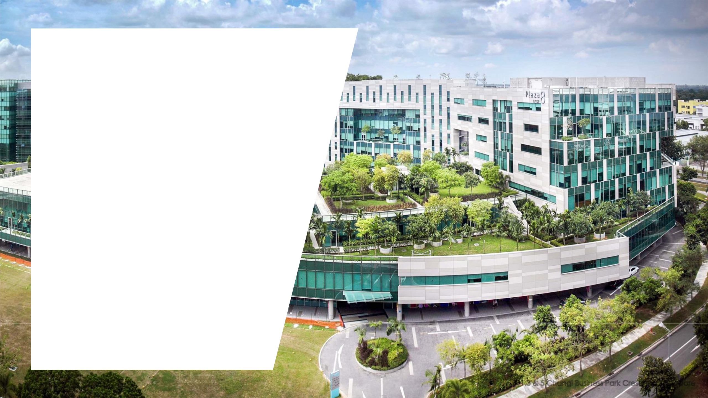

**Capital Management**

1,3 & 5 Changi Business Park Crescent, Singapore

21

**Healthy Balance Sheet**

* Aggregate leverage improved to 35.1% (2)
* Available debt headroom of ~S$1.1 b to reach 40.0% aggregate leverage

|  |  |  |  |  |
| --- | --- | --- | --- | --- |
|  | **As at** | **As at** | **As at** |  |
|  | **31 Dec 2019** | **30 Sep 2019** | **31 Dec 2018** |  |
|  |  |  |  |  |
| Total Debt (S$m) (1) | **4,653** | 4,135 | 4,136 |  |
| Total Assets (S$m) (2) |  | 11,425 | 11,260 |  |
| **13,246** |  |
| Aggregate Leverage (2) |  | 36.2% | 36.7% |  |
| **35.1%** |  |
| Unitholders' Funds (S$m) | **7,810** | 6,633 | 6,503 |  |
| Net Asset Value (NAV) per Unit |  | 213 cents | 209 cents |  |
| **216 cents** |  |
| Adjusted NAV per Unit (3) |  | 205 cents | 205 cents |  |
| **213 cents** |  |
| Units in Issue (m) |  | 3,113 | 3,111 |  |
| **3,613**(4) |  |
|  |  |  |  |  |

1. Excludes fair value changes and amortised costs. Borrowings denominated in foreign currencies are translated at the prevailing exchange rates except for JPY/HKD-denominated debt issues, which are translated at the cross-currency swap rates that Ascendas Reit has committed to.
2. Excludes the effects of FRS 116.
3. Adjusted for the amount to be distributed for the relevant period after the reporting date.
4. 498 million new Units were issued on 6 December 2019 in relation to the Rights Issue.

22

**Well-spread Debt Maturity Profile**

* Well-spread debt maturity with the longest debt maturing in FY2029
* Average debt maturity improved to 4.0 years (Sep 2019: 3.6 years; Dec 2018: 3.6 years)
* Entered into new USD Loan Facilities in 3Q FY2019 to ensure a high level of natural hedge in the United States

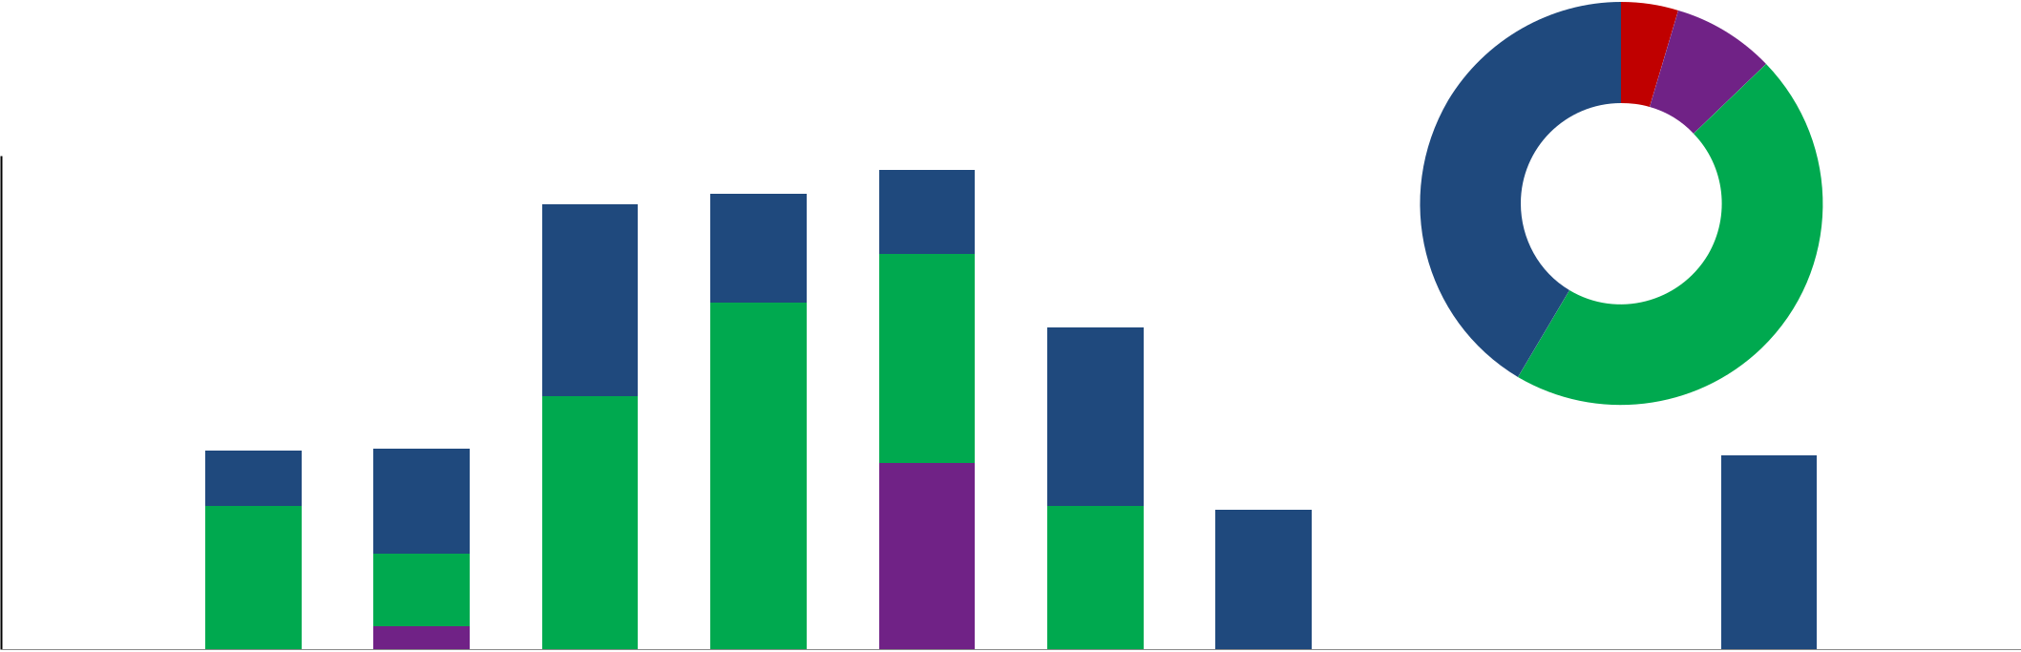

|  |
| --- |
| **S$ (million)** |

900

800

700

600

500

400

300

200

100

0

|  |  |  |  |  |  |  |  |  |  |  |  |  |  |  |  |  |  |
| --- | --- | --- | --- | --- | --- | --- | --- | --- | --- | --- | --- | --- | --- | --- | --- | --- | --- |
|  |  |  |  |  |  |  |  |  |  |  |  |  |  | 5% 8% | |  |  |
|  |  |  |  |  |  |  | **811** | **831** | **875** |  |  |  | 41% |  |  |  |  |
|  |  |  |  |  |  |  | 154 |  |  |  |  |  |  |  |
|  |  |  |  |  |  |  |  | 200 |  |  |  |  |  |  |  |  |
|  |  |  |  |  |  |  |  |  |  |  |  |  |  |  |  |  |
|  |  |  |  |  |  |  | 350 |  |  | **587** | |  |  |  | 46% |  |  |
| - - | | | |  |  |  |  |  | 381 |  |  |  |  |  |  |  |  |
|  | **362** | **367** |  |  |  | 325 | |  |  |  | **353** |  |  |
|  |  |  | - | |  |  |  |  |  |  |  |  |
|  |  |  | 100 |  |  | 631 |  |  |  | **254** |  |  |  |  |  |
| **212** | |  |  |  | 192 |  |  |  |  |  |  |  |  |  |
|  |  |  |  | 461 |  |  |  |  |  |  |  |  |  |  |
|  |  |  |  |  | 262 | 132 |  | 340 | 262 | | 254 |  |  | 353 |  |  |
|  | 212 |  |  |  |  |  |  |  |  |
|  |  |  |  |  |  |  |  |  |  |
|  |  |  |  |  |  |  |  |  |  |  |  |
|  |  |  |  |  | - | 42 | - | - |  | - | | - | - | - | - | - |  |
|  |  |  |  |  |  |  |  |
| FY2019 | | |  |  | FY2020 | FY2021 | FY2022 | FY2023 | FY2024 | FY2025 | | FY2026 | FY2027 | FY2028 | FY2029 | FY2030 |  |
|  |  |  |  |  |  |  |  |  |  |  |  |  |  |  |  | and |  |
|  |  |  |  | Revolving Credit Facilities | | | |  |  |  | Committed Revolving Credit Facilities | | | |  | beyond |  |
|  |  |  |  |  |  |  |  |  |
|  |  |  |  |  |  |  |  |  |
|  |  |  |  | Term Loan Facilities | | |  |  |  |  | Medium Term Notes | | |  |  | 23 |  |
|  |  |  |  |  |  |  |  |  |  |  |
|  |  |  |  |  |  |  |  |  |  |  |
|  |  |  |  |  |  |  |  |  |  |  |  |  |  |  |  |  |

**Key Funding Indicators**

* Robust financial metrics that exceed bank loan covenants by a healthy margin
* Enable access to wider funding options at competitive rates

Aggregate Leverage (1)

Unencumbered Properties as % of Total Investment Properties (3)

Interest Cover Ratio

Total Debt / EBITDA

Weighted Average Tenure of Debt (years) Weighted Average all-in Debt Cost

**Issuer Rating by Moody’s**

|  |  |  |
| --- | --- | --- |
| **As at** | **As at** | **As at** |
| **31 Dec 2019** | **30 Sep 2019** | **31 Dec 2018** |
| 35.1% (2) | 36.2% (2) | 36.7% |
| 91.8% | 90.9% | 91.0% |
| 5.1 x (2) | 5.3 x (2) | 5.3 x |
| 7.5 x (2)(4) | 6.4 x (2) | 7.1 x |
| 4.0 | 3.6 | 3.6 |
| 2.9% | 3.0% | 3.0% |
| **A3** | A3 | A3 |

1. Based on total gross borrowings divided by total assets. Correspondingly, the ratio of total gross borrowings to unitholders’ funds is 59.6%.
2. Exclude the effects of FRS 116.
3. Total investment properties exclude properties reported as finance lease receivable.
4. Increase in total debt/ EBITDA due to debt being drawn down for the US and Singapore acquisitions in Dec 2019 but contribution to earnings was only from 11 Dec 2019 to 31 Dec 2019.

24

**High Level of Currency Hedge**

* Maintained high level of natural hedge Australia (73.8%), the United Kingdom (100%) and United States (75.8%) to minimise the effects of adverse exchange rate fluctuations

|  |
| --- |
| **S$ (billion)** |

|  |  |  |  |
| --- | --- | --- | --- |
|  |  | **AUD** |  |
|  | **Natural Hedge** | |  |
| 1.8 | **A$1.7 b** | **73.8%** |  |
|  |  |
| 1.6 | **(S$ 1.6 b)** |  |  |
|  |  |  |

|  |  |  |  |  |  |  |
| --- | --- | --- | --- | --- | --- | --- |
| 1.4 |  |  | **A$1.3 b** | | |  |
| 1.2 |  |  | **(S$ 1.2 b)** | | |  |
|  |  |  |  |  |  |
| 1.0 |  |  |  |  |  |  |
| 0.8 |  |  |  |  |  |  |
| 0.6 |  |  |  |  |  |  |
| 0.4 |  |  |  |  |  |  |
| 0.2 |  |  |  |  |  |  |
| 0.0 |  |  |  |  |  |  |
|  | **Total Australia** | **Total Australia** | | |  |
|  |  |  |
|  |  | **Assets** | **Borrowings** | | |  |

|  |  |  |
| --- | --- | --- |
| **GBP** | **USD** |  |
| **Natural Hedge** | **Natural Hedge** | |
| **100%** | **75.8%** | (1) |

|  |  |  |  |  |
| --- | --- | --- | --- | --- |
|  |  | **US$1.0 b** |  |  |
|  |  | **(S$ 1.3 b)** |  |  |
|  |  |  | **US$0.7 b** |  |
| **£0.5 b** | **£0.5 b** |  | **(S$ 1.0 b)** |  |
|  |  |  |
| **(S$ 0.8 b)** | **(S$ 0.8 b)** |  |  |  |
| **Total United** | **Total United** | **Total United States** | **Total United States** |  |
| **Kingdom Assets** | **Kingdom** | **Assets** | **Borrowings** |  |
|  | **Borrowings** |  |  |  |

|  |  |  |
| --- | --- | --- |
| (1) Natural hedge for United States is expected to increase to approximately 100% in the Jan – Mar 2020 quarter. | 25 |  |
|  |  |

**Prudent Interest Rate Risk Management**

* 75.8% of borrowings are on fixed rates with an average term of 3.3 years
* 50 bps increase in interest rate is expected to have a pro forma impact of S$4.2m decline in distribution or 0.12 cent decline in DPU

|  |  |  |  |
| --- | --- | --- | --- |
|  | **Change in** | **Change as** | **Pro Forma** |
| **Change in Interest Rates** | **Distribution** | **% of FY2019** | **DPU Impact** |
|  | **(S$m) (1)** | **Distribution** | **(cents) (1)(2)** |
| +50 bps | -4.2 | -1.1% | -0.12 |
| +100 bps | -8.4 | -2.3% | -0.23 |
|  |  |  |  |
| +150 bps | -12.7 | -3.4% | -0.35 |
|  |  |  |  |
| +200 bps | -16.9 | -4.5% | -0.47 |
|  |  |  |  |

1. Based on 9 months distribution from 1 Apr 2019 to 31 Dec 2019.
2. Based on number of Units in issue of 3,613m as at 31 Dec 2019.

26



**Annual Property Revaluation**

* Total valuation of 198 properties was **S$12.84 b** (excludes 25 & 27 Ubi Road 4 which are under redevelopment)
* Stable same-store valuation for 168 properties(1) at S$11.13 b (vs. S$11.10 b @ 31 Mar 2019)

|  |  |  |  |
| --- | --- | --- | --- |
| **As at 31 Dec 2019** | **Valuation (S$b)** | **Weighted Average Cap Rates** | **Cap Rates Range** |
|  |  |  |  |
| ***Singapore portfolio (97 properties)*** | **9.16** | **6.02%** | **5.25% - 7.25%** |
|  |  |  |  |
| Business & Science Parks | 4.13 | 5.81% | 5.25% - 6.00% |
| High-Specifications/Data Centres | 2.21 | 6.28% | 5.50% - 6.90% |
|  |  |  |  |
| Light Industrial/Flatted Factories (2) | 0.91 | 6.33% | 6.00% - 7.25% |
| Logistics & Distribution Centres | 1.18 | 6.14% | 5.75% - 6.75% |
| Integrated Development, Amenities & Retail | 0.73 | 5.85% | 5.25% - 6.50% |
|  |  |  |  |
| ***Australia portfolio (35 properties)(3)*** | **1.57** | **5.88%** | **5.00% - 6.75%** |
| Suburban Offices | 0.32 | 6.23% | 6.00% - 6.75% |
| Logistics & Distribution Centres | 1.25 | 5.79% | 5.00% - 6.75% |
|  |  |  |  |
| ***United Kingdom portfolio (38 properties) (4)*** | **0.80** | **5.82%(5)** | **4.42% - 8.15%(5)** |
| ***United States portfolio (28 properties) (6)*** | **1.31** | **6.27%** | **5.75% - 7.25%** |
|  |  |  |  |
| **Total Portfolio (198 properties)** | **12.84** |  |  |
|  |  |  |  |

1. Excludes 1 property which was divested in FY2019 (8 Loyang Way 1), 2 properties under redevelopment (25 & 27 Ubi Road 4) and 30 properties acquired in FY2019 (US properties, Nucleos and FM Global Centre).
2. Excludes 25 & 27 Ubi Road 4, which are under redevelopment.
3. All S$ amount based on exchange rate of A$1.00: S$0.92791 as at 31 Dec 2019.
4. All S$ amount based on exchange rate of £1.00: S$1.75468 as at 31 Dec 2019.
5. Refers to equivalent yield, which reflects the current level of return on property investments in the United Kingdom.
6. All S$ amount based on exchange rate of US$1.00: S$1.36055 as at 31 Dec 2019.



**Asset**

**Management**

Infineon Building , Singapore

28

**Overview of Portfolio Occupancy**

|  |  |  |  |  |  |  |  |  |  |  |  |
| --- | --- | --- | --- | --- | --- | --- | --- | --- | --- | --- | --- |
|  |  | **97.4%** | 95.4% | 98.1% | **97.7%** | 97.7% | 100.0% |  |  |  |  |
|  |  |  |  |  |  |  | **93.9%** | **90.9%** | 91.0% | 91.3% |  |
| **87.2%** | 88.1% | 87.3% |  |  |  |  |  |  |
|  |  |  |  |  |  |  |  |  |



|  |  |  |  |  |  |  |  |  |  |  |  |  |  |  |
| --- | --- | --- | --- | --- | --- | --- | --- | --- | --- | --- | --- | --- | --- | --- |
|  |  |  |  |  |  |  |  |  |  |  | N.A. N.A. |  |  |  |
|  |  |  |  |  |  |  |  | |  |  |  |  |  |  |
|  |  |  |  |  |  |  |  | |  |  |  |  |  |  |
|  | Singapore | Australia | | |  |  | United Kingdom | | | | United States | Total |  |  |
|  |  |  |  | Dec-19 |  |  | Sep-19 |  | Dec-18 | |  |  |  |  |
|  |  |  |  |  |  |  |  |  |  |
|  |  |  |  |  |  |  |  |  |  |
|  |  |  |  |  |  |  |  |  |  |  |  |  |  |  |
| **Gross Floor** | **3,061,210** | **792,039**(2) |  |  | **509,907** (3) | | |  |  |  | **313,059** | **4,676,215** |  |  |
| **Area (sqm)** (1) |  |  |  |  |  |  |  |
|  |  |  |  |  |  |  |  |  |  |  |  |  |  |
|  |  |  |  |  |  |  |  |  |  |  |  |  |  |  |

1. Gross Floor Area as at 31 Dec 2019.
2. Gross Floor Area for Australia portfolio refers to the Gross Lettable Area/Net Lettable Area.

|  |  |
| --- | --- |
| (3) Gross Floor Area for United Kingdom portfolio refers to the Gross Internal Area. | 29 |

**Singapore: Occupancy**

* Occupancy fell to 87.2% mainly due to lower occupancies at Wisma Gulab *(31 Dec 2019: 0%, 30 Sep 2019:*

*100%)*, 40 Penjuru Lane *(31 Dec 2019: 80.6%, 30 Sep 2019: 87.8%)*and Pioneer Hub *(31 Dec 2019: 95.4%, 30 Sep 2019:*

*99.3%)*

|  |  |  |  |  |  |  |
| --- | --- | --- | --- | --- | --- | --- |
|  | **As at** | **31 Dec 2019** | **30 Sep 2019** | **31 Dec 2018** |  |  |
|  |  |  |  |  |  |  |
|  | Total Singapore Portfolio GFA (sqm) | 3,061,210(1)(2) | 3,003,420(1)(2) | 3,034,122 |  |  |
|  | Singapore Portfolio Occupancy | 87.1% | 88.1% | 87.3% |  |  |
|  | (same store) (3) |  |  |
|  |  |  |  |  |  |
|  | Singapore MTB Occupancy (same store) (4) | 83.7% | 84.6% | 83.4% |  |  |
|  | Occupancy of Singapore Investments | 93.7% | N.A. | 91.1% |  |  |
|  | Completed in the last 12 months |  |  |
|  |  |  |  |  |  |
|  |  |  |  |  |  |  |
|  | **Overall Singapore Portfolio Occupancy** | **87.2%** | **88.1%** | **87.3%** |  |  |
|  | **Singapore MTB Occupancy** | **83.4%** | **84.6%** | **83.0%** |  |  |
|  |  |  |  |  |  |  |

* Please refer to slide 43 for more information on the iQuest@IBP redevelopment.

1. Excludes 25 Ubi Road 4 and 27 Ubi Road 4 which were decommissioned for redevelopment since Jun 2019
2. Excludes 8 Loyang Way 1 which was divested on 18 Sep 2019.
3. Same store portfolio occupancy rates for previous quarters are computed with the same list of properties as at 31 Dec 2019, excluding new investments completed in the last 12 months and divestments.
4. Same store MTB occupancy rates for previous quarters are computed with the same list of properties as at 31 Dec 2019, excluding new investments completed in the last 12 months, divestments and changes in classification of certain buildings from single-tenant to multi-tenant buildings or vice-versa.

30

**Australia: Occupancy**

* Occupancy improved to 97.4% mainly due to new take up at 62 Stradbroke Street, Brisbane *(31 Dec 2019:* *100%, 30 Sep 2019: 61.7%)* and the decommissioning of partial space at 484-490 and 494-500 Great WesternHighway (Sydney) for asset enhancement works

|  |  |  |  |  |  |  |
| --- | --- | --- | --- | --- | --- | --- |
|  | **As at** | **31 Dec 2019** | **30 Sep 2019** | **31 Dec 2018** |  |  |
|  |  |  |  |  |  |  |
|  | Total Australian Portfolio GFA (sqm) | 792,039(1) | 810,536 | 810,771 |  |  |
|  | Australian Portfolio Occupancy | 97.4% | 95.4% | 98.1% |  |  |
|  | (same store) (2) |  |  |
|  |  |  |  |  |  |
|  | Occupancy of Australian Investments | N.A. | N.A. | 100% |  |  |
|  | Completed in the last 12 months |  |  |
|  |  |  |  |  |  |
|  | **Overall Australian Portfolio Occupancy** | **97.4%** | **95.4%** | **98.1%** |  |  |
|  |  |  |  |  |  |  |

1. The decrease in GFA was due to decommissioning of partial space at 484-490 and 494-500 Great Western Highway to facilitate AEI works to improve leasing outcomes.
2. Same store portfolio occupancy rates for previous quarters are computed with the same list of properties as at 31 Dec 2019, excluding new investments completed in the last 12 months.

31

**United Kingdom: Occupancy**

* Occupancy was stable at 97.7%

|  |  |  |  |  |  |  |
| --- | --- | --- | --- | --- | --- | --- |
|  | **As at** | **31 Dec 2019** | **30 Sep 2019** | **31 Dec 2018** |  |  |
|  |  |  |  |  |  |  |
|  | Total United Kingdom Portfolio GFA (sqm) | 509,907 | 509,907 | 509,032 |  |  |
|  |  |  |  |  |  |  |
|  | Occupancy of United Kingdom Investments | N.A. | 97.7% | 100.0% |  |  |
|  | Completed in the last 12 months |  |  |
|  |  |  |  |  |  |
|  | **Overall United Kingdom Portfolio** | **97.7%** | **97.7%** | **100.0%** |  |  |
|  | **Occupancy** |  |  |
|  |  |  |  |  |  |
|  |  |  |  |  |  |  |

32

**Singapore: Sources of New Demand (3Q FY2019)**

* Continues to attract demand from a wide spectrum of industries

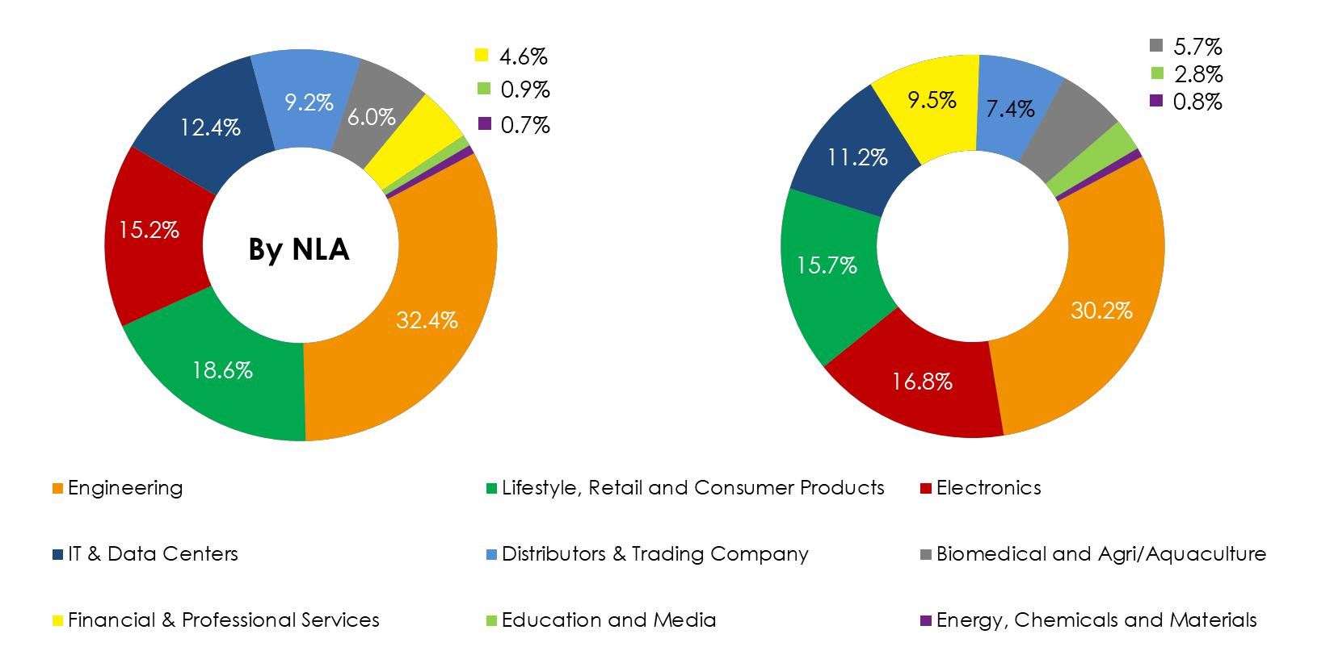

**By Gross**

**Rental**

**Income**

|  |  |  |
| --- | --- | --- |
| Note: Customers’ Industry classifications have been updated to better reflect the organisation’s primary industry sector. Previous industry classifications were based on the | 33 |  |
| Singapore Standard Industrial Classification (SSIC) which may be outdated due to changes in business activities. |  |
|  |  |

**Singapore: Sources of New Demand (FY2019)**

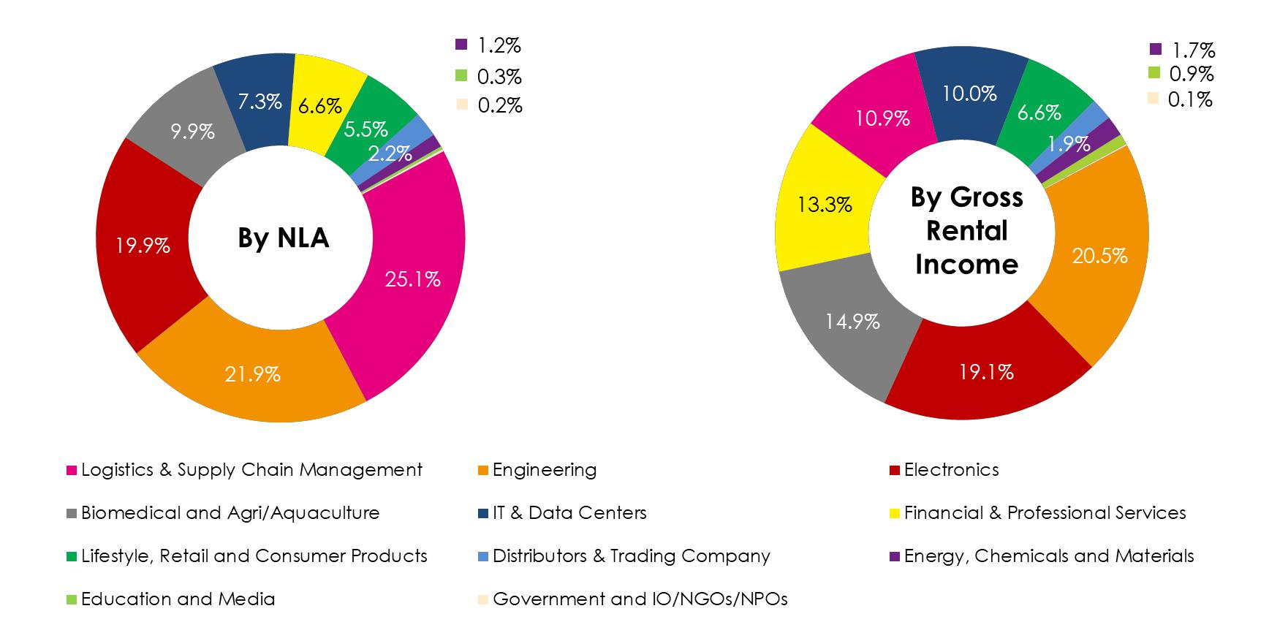

|  |  |  |
| --- | --- | --- |
| Note: Customers’ Industry classifications have been updated to better reflect the organisation’s primary industry sector. Previous industry classifications were based on the | 34 |  |
| Singapore Standard Industrial Classification (SSIC) which may be outdated due to changes in business activities. |  |
|  |  |

**Portfolio Rental Reversions**

* Average portfolio rent reversion of +6.0% was recorded for leases renewed in FY2019
* Rental reversion for FY2020 is expected to be a low single-digit improvement in view of the current global uncertainty

|  |  |  |  |  |  |  |
| --- | --- | --- | --- | --- | --- | --- |
|  |  |  |  |  |  |  |
|  | **% Change in Renewal Rates for Multi-tenant Buildings (1)** | **FY2019** | **FY18/19** | **3Q FY2019** | **3Q FY18/19** |  |
|  | **Singapore** | **6.2%** | **3.7%** | **8.8%** | **3.2%** |  |
|  |  |  |  |  |  |  |
|  | Business & Science Parks | 9.2% | 4.3% | 11.8% | 5.4% |  |
|  | High-Specifications Industrial and Data Centres | 3.3% | 2.0% | 4.4% | 1.7% |  |
|  |  |  |  |  |  |  |
|  | Light Industrial and Flatted Factories | 2.1% | 3.5% | 0.9% | 4.5% |  |
|  | Logistics & Distribution Centres | 4.9% | 2.5% | 3.1% | 1.7% |  |
|  |  |  |  |  |  |  |
|  | Integrated Development, Amenities & Retail | 0.7% | 7.9% | 1.4% | 10.3% |  |
|  |  |  |  |  |  |  |
|  | **Australia** | **1.0%** | **- (2)** | **- (2)** | **- (2)** |  |
|  | Suburban Offices | 1.9% | - (2) | - (2) | - (2) |  |
|  | Logistics & Distribution Centres | -9.9% | - (2) | - (2) | - (2) |  |
|  | **Total Portfolio(3) :** | **6.0%** | **3.7%** | **8.8%** | **3.2%** |  |

|  |  |  |  |
| --- | --- | --- | --- |
| (1) | Percentage change of the average gross rent over the lease period of the renewed leases against the preceding average gross rent from lease start date. Takes into account renewed leases | |  |
|  | that were signed in their respective periods and average gross rents are weighted by area renewed. |  |  |
| (2) | There were no renewals signed in the period for the respective segments. | 35 |  |
| (3) | There were no multi-tenant leases due for renewal during FY2019 in the UK and the US (since acquisition date on 11 Dec 2019). |  |
|  |  |

**Weighted Average Lease Expiry**

**(By gross revenue)**

* Portfolio Weighted Average Lease Expiry (WALE) stood at 3.9 years

|  |  |
| --- | --- |
| **WALE (as at 31 December 2019)** | **Years** |
|  |  |
| Singapore | 3.5 |
| Australia | 4.4 |
| United Kingdom | 8.8 |
| United States | 4.1 |
|  |  |
| **Portfolio** | **3.9** |
|  |  |

36

**Portfolio Lease Expiry Profile**

**(as at 31 Dec 2019)**

▪ Portfolio weighted average lease to expiry (WALE) of 3.9 years

**Breakdown of expiring leases**



**for FY2020 and FY2021**

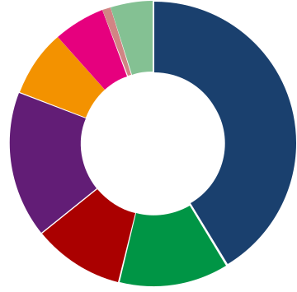

**6%** **5%**

▪ Lease expiry is well-spread, extending beyond FY2033

**8%**

**1%**

**41%**

▪ About 19.4% of gross rental income is due for renewal in FY2020

▪ Weighted average lease term of new leases (1) signed in 3Q FY2019 was 5.2

years and contributed 2.8% of 3Q FY2019 total gross revenue

|  |  |  |  |  |  |  |  |  |  |  |  |  |  |  |  |  |  |  |  |
| --- | --- | --- | --- | --- | --- | --- | --- | --- | --- | --- | --- | --- | --- | --- | --- | --- | --- | --- | --- |
| **(TotalPortfolio)** | **19.4%** |  | **19.3%** |  |  |  |  |  |  |  |  |  |  |  |  |  |  |  |  |
|  | **17.1%** |  |  |  |  |  |  |  |  |  |  |  |  |  |  |  |  |  |
|  |  |  |  |  |  |  |  |  |  |  |  |  |  |  |  |  |  |  |
| **Income** |  |  |  | **12.4%** |  |  |  |  |  |  |  |  | Multi-tenant Buildings | | | |  |  |  |
|  |  |  |  |  |  |  |  |  |  |  |  |  |  |
|  |  |  |  |  |  |  |  |  |  |  |  |  |  |
| 14.5% |  | 16.0% |  |  |  |  |  |  |  |  |  | Single-tenant Buildings | | | | |  |  |
|  |  |  |  |  |  |  |  |  |  |  |  |  |
|  |  |  |  |  |  |  |  |  |  |  |  |  |
|  |  |  |  |  |  |  |  |  |  |  |  |  |  |  |  |  |  |  |
| **Rental** |  | 14.2% |  | 10.3% |  | **5.6%** | **5.7%** |  |  |  |  |  |  |  |  |  |  |  |  |
|  |  |  | **6.5%** |  |  |  |  |  |  |  |  |  |  |  |  |
| **Gross** |  |  |  |  |  |  |  |  |  |  |  |  |  |  |  |  |  |  |
|  |  |  |  | 5.0% | 3.7% | 1.1% |  | **1.9%** | **2.6%** | **1.9%** | | |  |  |  | **3.3%** | **1.9%** |  |
|  |  |  |  |  |  |  |  |  |  |  |  |  |
| **of** | 4.9% |  |  |  |  |  | 4.6% | **0.6%** | 1.6% | **0.9%** | **0.9%** |  |  |  |
| 2.8% | 3.2% |  |  |  | 0.6% | 0.3% | | |  | 3.3% |  |  |
|  |  |  |  |  |  |  |  |  |  |  |  |
| **%** |  | 2.1% | 1.5% | 1.9% |  | 0.5% | 1.0% | 0.9% | 0.9% |  | 1.9% |  |
|  |  |  |  | 1.3% | 1.6% | | |  |  |  |
|  |  |  |  |  |  |  |  | 0.1% |  |  |  |  |  |  |  |  |  | FY33 |  |
|  |  |  |  |  |  |  |  |  |  |  |  |  |  |  |  |  |  |
|  | FY20 | FY21 | FY22 | FY23 | FY24 | FY25 | FY26 | FY27 | FY28 | FY29 |  |  | FY30 | FY31 | FY32 | | FY33 |  |
|  |  |  |  |  |  |  |  |  |  |  |  |  |  |  |  |  |  | > |  |

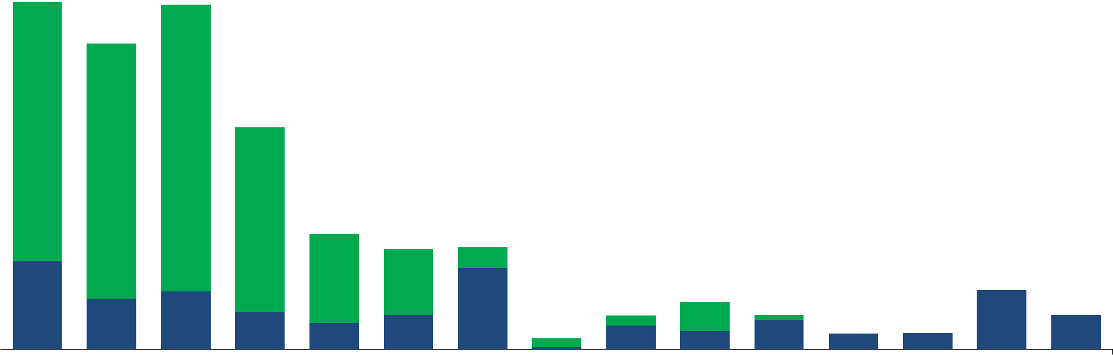

(1) New leases refers to new, expansion and renewal leases. Excludes leases from new acquisitions.

**17%** **FY2020**

**10%** **12%**

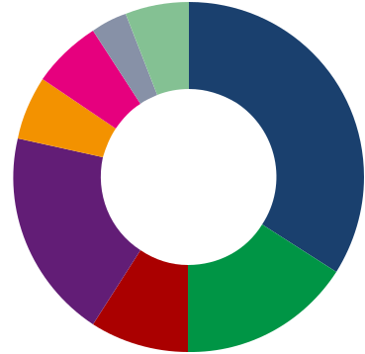

**3%6%**

**6%**

**6%** **34%**

**FY2021**

**19%**

**9%** **16%**

 Business and Science Parks

 High-Specifications Industrial and Data Centres

 Light Industrial and Flatted Factories

 Logistics & Distribution Centres

 Integrated Development, Amenities & Retail

 Logistics & Suburban Offices (Australia)

 Logistics & Distribution Centres (UK)

 Business Parks (US)

37

|  |
| --- |
| **% of Gross Rental Income (Singapore)** |

**Singapore: Lease Expiry Profile**

**(as at 31 Dec 2019)**

* Singapore portfolio weighted average lease to expiry (WALE) of 3.5 years
* Lease expiry is well-spread, extending beyond FY2033
* 23.3% of Singapore’s gross rental income is due for renewal in FY2020

**23.3%**



**20.9%**

**19.6%**

|  |  |  |  |  |  |  |  |  |  |  |  |  |  |  |  |  |  |  |  |  |  |  |  |  |  |  |  |  |  |  |  |  |  |
| --- | --- | --- | --- | --- | --- | --- | --- | --- | --- | --- | --- | --- | --- | --- | --- | --- | --- | --- | --- | --- | --- | --- | --- | --- | --- | --- | --- | --- | --- | --- | --- | --- | --- |
| 18.6% | |  |  |  |  | **11.7%** | |  |  |  |  |  |  |  |  |  |  |  |  |  |  |  | Multi-tenant Buildings - SG | | | | | | |  |  |  |  |
|  |  |  |  |  |  |  |  |  |  |  |  |  |  |  |  |  |  |  |  |  |  |  |  |  |
|  |  |  |  |  |  |  |  |  |  |  |  |  |  |  |  |  |  |  |  |  |  |  |  |  |
|  |  |  |  |  |  |  |  |  |  |  |  |  |  |  |  |  |  |  |  |  | Single-tenant Buildings - SG | | | | | | |  |  |  |  |
|  |  | 18.3% | | 18.5% | |  |  |  |  |  |  |  |  |  |  |  |  |  |  |  |  |  |  |  |  |  |
|  |  |  |  |  |  |  |  |  |  |  |  |  |  |  |  |  |  |  |  |  |  |  |
|  |  |  |  |  |  |  |  |  |  |  |  |  |  |  |  |  |  |  |  |  |  |  |
|  |  |  |  |  |  |  |  |  |  |  |  |  |  |  |  |  |  |  |  |  |  |  |  |  |  |  |  |  |  |  |  |
|  |  |  |  |  |  | 11.1% | |  |  | **5.6%** | |  |  |  |  |  |  |  |  |  |  |  |  |  |  |  |  |  |  |  |  |  |  |
|  |  |  |  |  |  |  |  |  |  | **3.8%** | |  |  |  |  |  |  |  |  |  |  |  |  |  |  | **4.2%** | |  |  |  |  |
|  |  |  |  |  |  |  |  | **3.3%** | |  |  |  |  |  |  |  |  |  |  |  |  |  |  |  |  |  |  |  |  |
|  |  |  |  |  |  |  |  |  |  |  |  |  |  |  |  |  |  |  |  |  |  |  |  |  |  |  |  |  |  |
|  |  |  |  |  |  |  |  | 3.7% | | 0.3% | |  |  |  |  | **2.1%** | | **2.2%** | | | |  |  |  |  |  |  |  |  |  |  |
|  |  |  |  |  |  |  |  |  |  |  |  |  |  |  |  |  |  |  |  | **1.9%** | |  |  |
| 4.7% | |  |  |  |  |  |  |  |  |  |  |  |  |  |  | **0.6%** | |  |  | **0.7%** | | 4.2% | |  |  |
|  |  |  |  |  |  | 2.7% | |  |  | 3.5% | | **0.0%** | |  |  |  |  |  |  | **0.0%** | |  |  |  |  |
|  |  |  |  | 2.4% | |  |  | 1.8% | | 1.6% | | 2.2% | | | | 1.9% | |  |  |
|  |  | 1.3% | | 0.7% | | 0.6% | |  |  | 0.6% | | 0.7% | |  |  |  |  |
|  |  |  |  |  |  |  |  |  |  | 0.6% | |  |  |  |  |  |  |  |  |  |  |  |  |
|  |  |  |  |  |  |  |  |  |  |  |  |  |  |  |  |  |  |  |  |  |  |  |  |
|  | FY20 |  | FY21 |  | FY22 |  | FY23 |  | FY24 |  | FY25 |  | FY26 |  | FY27 |  | FY28 |  | FY29 |  |  | FY30 | |  | FY31 |  | FY32 |  | FY33 |  | FY33 | |  |
|  |  |  |  |  |  |  |  |  |  |  |  |  |  |  |  |  |  |  |  |  |  |  |  |  |  |  |  |  |  | > | |  |  |

**Breakdown of expiring leases for FY2020 and FY2021**

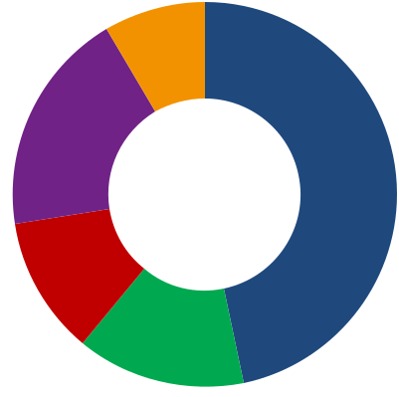

**9%**

**19%**

**FY2020** **47%**

**12%**

**14%**

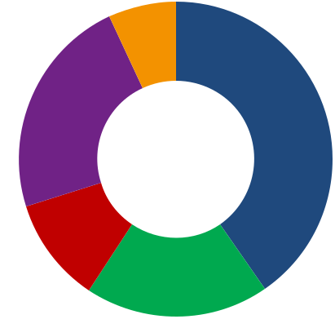

**7%**

**23%** **40%**

**FY2021**

**11%**

**19%**

 Business and Science Parks

 High-Specifications Industrial and

Data Centres

 Light Industrial and Flatted

Factories

 Logistics & Distribution Centres

 Integrated Development,

Amenities & Retail

38

**Australia: Lease Expiry Profile**

**(as at 31 Dec 2019)**

* Australia portfolio weighted average lease to expiry (WALE) of 4.4 years
* Lease expiry is well-spread, extending beyond FY2030
* 10.4% of Australia’s gross rental income is due for renewal in FY2020

**18.9%**



**15.0%**

|  |  |  |  |  |  |  |  |  |  |  |  |  |  |  |  |  |  |  |  |  |  |  |  |  |  |  |  |  |
| --- | --- | --- | --- | --- | --- | --- | --- | --- | --- | --- | --- | --- | --- | --- | --- | --- | --- | --- | --- | --- | --- | --- | --- | --- | --- | --- | --- | --- |
| **(Australia)** |  |  |  |  | **13.1%** | | 9.1% | |  |  |  |  |  |  |  |  |  |  |  |  |  |  |  |  |  |  |  |  |
|  |  |  |  |  |  |  |  |  |  |  |  |  |  |  |  |  |  |  |  |  |  |  |  |  |
|  |  |  |  |  |  |  |  |  |  |  |  |  |  |  |  |  |  |  |  |  |  |  |  |  |  |  |
|  |  |  |  |  |  |  |  |  |  |  |  |  | **12.0%** | |  |  |  |  |  |  |  |  |  |  |  |  |  |  |
| **Income** | **10.4%** | | **10.0%** | |  |  |  |  | 6.9% | |  |  | 2.0% | |  |  |  |  |  | Multi-tenant building - AUS | | | | |  |  |  |  |
|  |  |  |  |  |  |  |  |  |  |  |  |  |  |  |
|  |  |  |  |  |  |  |  |  |  |  |  |  |  |  |  |  |
|  |  |  |  |  |  |  |  |  |  |  |  |  |  |  |  |  |  |  |  |  |  |
| 2.2% | | 2.1% | |  |  |  |  |  |  |  |  |  |  |  |  |  |  |  | Single-tenant building - AUS | | | | |  |  |  |  |
|  |  |  |  |  |  |  |  |  |  |  |  |  |  |  |  |  |  |  |  |
|  |  |  |  |  |  |  |  |  |  |  |  |  |  |  |  |  |  |  |  |
|  |  |  |  |  |  |  |  |  |  |  |  |  |  |  |  |  |  |  |  |  |  |  |  |  |
| **Rental** |  |  |  |  |  |  |  |  |  |  |  |  |  |  |  |  |  |  |  |  |  |  |  |  |  |  |
|  |  |  |  | 10.8% | |  |  |  |  | **7.1%** | |  |  |  |  |  |  |  |  |  |  |  |  |  |  |  |  |
|  |  |  |  |  |  |  |  |  |  |  |  |  |  |  |  |  |  |  |  |  |  |  |  |  |
|  |  |  |  |  |  |  |  |  |  |  |  |  |  |  |  |  |  |  |  |  |  |  |  |  |  |  |
| **Gross** |  |  |  |  |  |  | 9.8% | |  |  | 5.5% | | 10.1% | |  |  |  |  |  |  | **3.7%** | |  |  | **3.3%** | |  |  |
|  |  |  |  |  |  |  |  |  |  |  |  |  |  |  |  |  |  |  |  |  |  |  |
| **of** | 8.2% | | 7.9% | |  |  |  |  | 8.1% | |  |  |  |  |  |  | **2.5%** | | | |  |  | **2.8%** | |  |  |
|  |  |  |  |  |  |  |  |  |  |  |  |  |  |  |  |  |  |  |  |  |  |
| **%** |  |  |  |  |  |  |  |  |  |  |  |  |  |  |  |  |  |  |  |  |  |  |  |  |  |  |  |  |
|  |  |  |  |  |  |  |  |  |  |  |  |  |  |  | **1.1%** | | 2.5% | | | | 3.7% | | 2.8% | | 3.3% | |  |  |
|  |  |  |  |  | 2.2% | |  |  |  |  |  |  |  |  |  |  |  |  |
|  |  |  |  |  |  |  |  |  | 1.6% | |  |  |  |  |  |  |  |  |
|  |  |  |  |  |  |  |  |  |  |  |  |  | 1.1% | |  |  |  |  |  |  |  |  |  |  |  |  |
|  |  |  |  |  |  |  |  |  |  |  |  |  |  |  |  |  |  |  |  |  |  |  |  |  |  |  |
|  |  |  |  |  |  |  |  |  |  |  |  |  |  |  |  |  |  |  |  |  |  |  |  |  |  |  |  |  |
|  |  | FY20 |  | FY21 |  | FY22 |  | FY23 |  | FY24 |  | FY25 |  | FY26 |  | FY27 |  |  | FY28 | |  | FY29 |  | FY30 |  | FY31 | |  |

**Breakdown of expiring leases for FY2020 and FY2021**

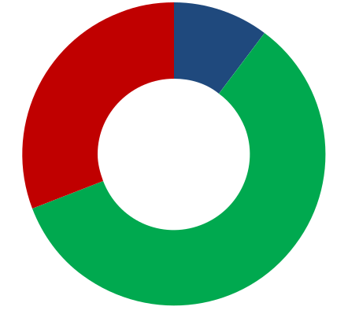

**10%**

**31%**

**FY2020**

**59%**

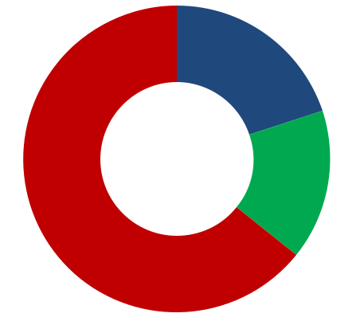

**20%**

**FY2021** **16%**

**64%**

 Sydney

 Melbourne

 Brisbane

39

**United Kingdom: Lease Expiry Profile**

**(as at 31 Dec 2019)**

**Breakdown of expiring leases**



**for FY2020 and FY2021**



* United Kingdom portfolio weighted average lease to expiry (WALE) of 8.8 years
* Lease expiry is well-spread, extending beyond FY2033
* 3.7% of United Kingdom’s gross rental income is due for renewal in FY2020

 Multi-tenant building - UK

**14.9%**

|  |  |  |  |  |  |  |  |  |  |  |  |  |  |  |  |  |  |  |  |  |  |  |  |  |  |  |  |  |  |  |  |  |  |  |
| --- | --- | --- | --- | --- | --- | --- | --- | --- | --- | --- | --- | --- | --- | --- | --- | --- | --- | --- | --- | --- | --- | --- | --- | --- | --- | --- | --- | --- | --- | --- | --- | --- | --- | --- |
| **Kingdom)** |  |  | **11.8%** | |  |  |  |  |  |  |  |  |  |  |  |  |  |  |  |  |  |  |  |  |  | Single-tenant building - UK | | | | | | | |  |
|  |  |  |  |  |  |  |  |  |  |  |  |  |  |  |  |  |  |  |  |  |  |  |  |  |
|  |  |  |  |  |  |  |  |  |  |  |  |  |  |  |  |  |  |  |  |  |  |  |  |  |
|  |  |  |  |  |  |  |  |  |  |  |  |  |  |  |  |  |  |  |  |  |  |  |  |  |  |  |  |  | **11.9%** | |  |  |
|  |  |  |  |  |  |  |  |  |  |  |  |  |  |  |  |  |  |  |  |  |  |  | **10.7%** | | | |  |  |  |  |  |  |
| **(United** |  |  |  |  |  |  |  |  |  |  |  |  |  |  |  |  |  |  |  |  |  |  |  |  |  |  |  |  |  |  |
|  |  |  |  |  |  | **8.3%** | |  |  | **8.0%** | |  |  |  |  | **8.6%** | |  |  |  |  |  |  |  |  | **8.8%** | |  |  |  |  |  |  |
| **Income** |  |  |  |  |  |  |  |  |  |  |  |  |  |  |  |  |  |  |  |  |  |  |  |  |  |  |  |  |  |  |  |  |
|  |  |  |  |  |  | 1.8% | |  |  |  |  | 14.9% | |  |  |  |  |  |  |  |  |  |  |  |  |  |  |  |  |  |  |  |  |
|  |  |  |  |  |  |  |  |  |  |  |  |  |  |  |  |  |  |  |  |  |  |  |  |  |  |  |  |  |  |  |
| **Rental** |  |  | 11.8% | |  |  |  |  |  |  |  |  |  |  |  |  |  |  | **4.3%** | |  |  | 10.7% | | | |  |  | **4.5%** | | 11.9% | |  |  |
| **3.7%** | |  |  |  |  |  |  |  |  |  |  |  |  | **3.9%** | |  |  |  |  |  |  |  |  |  |  |
|  |  |  |  |  |  |  |  |  |  |  |  |  |  |  |  |  |  |  |  |  |  |  |
|  |  |  |  |  |  |  |  |  | 8.0% | |  |  | 8.6% | |  |  |  |  |  |  |  |  | 8.8% | |  |  |  |  |
|  |  |  |  |  |  |  |  |  |  |  |  |  |  |  |  |  |  |  |  |  |  |  |  |  |  |  |  |  |
| **Gross** |  |  |  |  |  |  | 6.5% | |  |  |  |  | 0.9% | |  |  |  |  |  |  |  |  |  |  |  |  |  |  |  |  |  |  |
| 3.7% | |  |  |  |  |  |  |  |  |  |  |  |  | 4.3% | |  |  |  |  |  |  |  |  |  |  |  |  |  |  |
|  |  |  |  |  |  |  |  |  |  |  |  |  |  |  |  |  |  |  |  |  |  |  |  | 4.5% | |  |  |  |  |
|  |  |  |  |  |  |  |  |  |  |  |  |  |  |  |  |  |  |  |  |  |  |  |  |  |  |  |  |  |  |  |  |  |
| **of** |  |  |  |  | **0.3%** | |  |  | **0.4%** | |  |  |  |  | 3.0% | |  |  |  |  | **0.0%** | |  |  |  |  |  |  |  |  |  |  |  |  |
|  |  |  |  |  |  |  |  |  |  |  |  |  |  |  |  |  |  |  |  |  |  |  |  |  |  |  |  |  |  |  |  |
| **%** |  |  |  |  |  |  |  |  |  |  |  |  |  |  |  |  |  |  |  |  |  |  |  |  |  |  |  |  |  |  |  |  |  |  |
|  | FY20 |  | FY21 |  | FY22 |  | FY23 |  | FY24 |  | FY25 |  | FY26 |  | FY27 |  | FY28 |  | FY29 |  | FY30 |  |  |  | FY31 |  | FY32 |  | FY33 |  | >FY33 | |  |
|  |  |  |  |  |  |  |  |  |  |  |  |  |  |  |  |  |  |  |

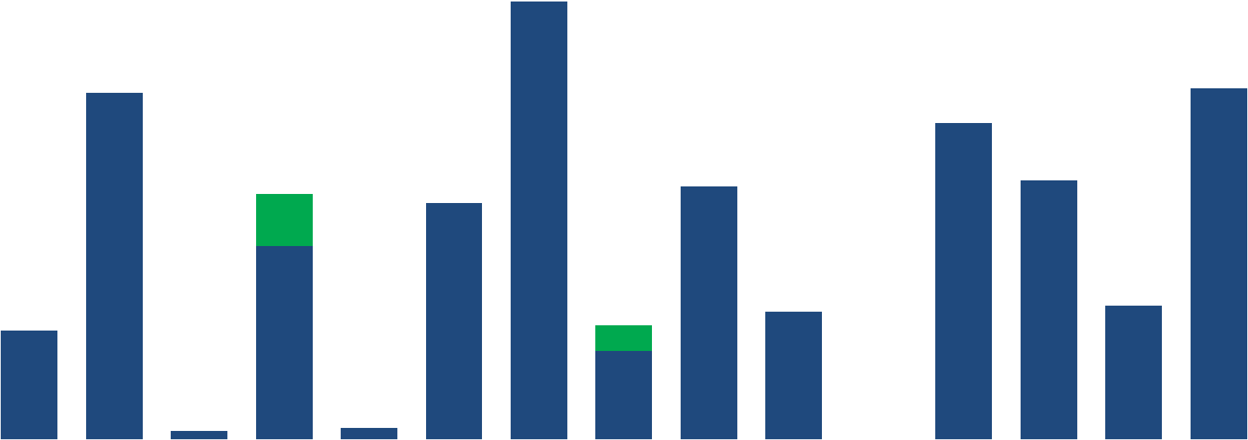

**FY2020**

**100%**

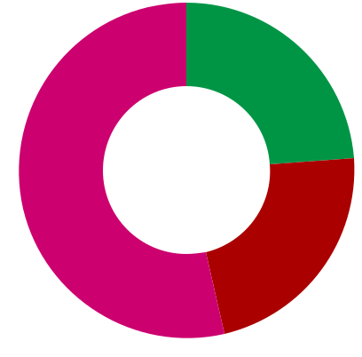

**24%**

**54%** **FY2021**

**22%**

 West Midlands

 East Midlands

 South East

40

**United States: Lease Expiry Profile**

**(as at 31 Dec 2019)**

* United States portfolio weighted average lease to expiry (WALE) of 4.1 years
* Lease expiry is well-spread, extending beyond FY2028
* 8.8% of United States’ gross rental income is due for renewal in FY2020

**Breakdown of expiring leases**



**for FY2020 and FY2021**

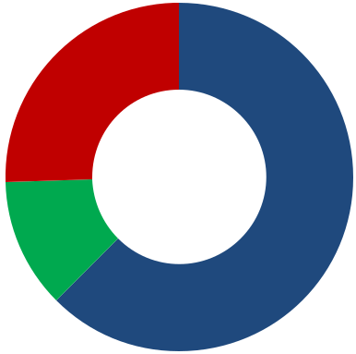

**25%**

**FY2020**

**22.8%**

**22.0%**



**12%** **63%**

|  |  |  |  |  |  |  |  |  |  |  |  |  |  |  |  |  |  |  |  |  |  |  |  |  |  |
| --- | --- | --- | --- | --- | --- | --- | --- | --- | --- | --- | --- | --- | --- | --- | --- | --- | --- | --- | --- | --- | --- | --- | --- | --- | --- |
| **States)** |  |  |  |  | 11.7% | |  |  |  |  |  |  |  |  |  | Multi-tenant building - US | | | | | | |  |  |  |
|  |  |  |  |  |  |  |  |  |  |  |  |  |  |  |  |  |
| **(United** |  |  |  |  |  |  |  |  |  |  |  |  |  |  |  |  |  |  |
|  |  |  |  |  |  |  |  |  |  |  |  |  |  |  |  |  |  |
|  |  |  |  |  |  |  |  |  |  |  |  |  |  |  |  |  |  |
|  |  |  |  |  |  | **12.3%** | |  |  |  |  |  |  |  | Single-tenant building - US | | | | | | |  |  |  |
| **Income** |  |  |  |  |  |  |  |  |  |  |  |  |  |  |  |  |
|  |  |  |  |  |  |  |  |  |  |  |  |  |  |  |  |
|  |  |  |  |  |  |  |  |  |  |  |  |  |  |  |  |  |  |  |  |  |  |  |
|  |  | **9.4%** | |  |  |  |  | 20.9% | |  |  |  |  |  |  |  |  |  |  |  |  |  |  |  |
|  |  |  |  |  |  |  |  |  |  |  |  |  |  |  |  |  |  |  |  |  |  |
|  | **8.8%** | |  |  |  |  |  |  |  |  |  |  |  |  |  |  |  |  |  |  |  |  |  |
| **Rental** |  |  |  |  |  |  |  |  |  |  | **7.8%** | |  |  |  |  |  |  |  |  |  |  |  |
|  |  |  |  |  |  |  |  |  |  |  |  |  |  |  |  | **6.8%** | |  |  |  |  |  |
|  |  |  |  |  |  |  |  |  |  |  |  |  |  |  |  |  |  |  |  |  |  |
|  |  |  |  |  |  |  | 10.5% | |  |  |  |  |  |  |  |  |  |  |  |  |  |  |  |
| **Gross** |  |  | 5.5% | |  |  |  |  |  |  |  |  |  |  |  |  |  |  |  |  |  |  |  |
| 5.3% | |  |  |  |  |  |  |  |  |  |  |  |  |  |  |  |  |  |  |  |  |  |
|  |  | 11.1% | |  |  |  |  |  |  |  |  |  |  |  |  |  |  |  |  | **4.3%** |  |  |
|  |  |  |  |  |  |  |  |  |  |  |  |  |  |  |  |  |  |  |  |  |
|  |  |  |  |  |  |  |  |  |  |  | 6.5% | |  |  |  |  |  |  |  |  |  |  |
| **of** |  |  |  |  |  |  |  |  |  |  | **3.0%** | |  |  |  |  | 5.3% | |  |  |  |  |  |
|  |  |  |  |  |  |  |  |  |  |  |  | **3.0%** | | | |  |  |  |  |  |
|  |  |  |  |  |  |  |  |  |  |  |  |  |  |  |  |  |  |  |  |  |
| **%** |  |  |  |  |  |  |  |  |  |  |  |  |  |  |  |  |  |  |  |  |  |
| 3.5% | | 3.9% | |  |  |  |  |  |  |  |  |  |  |  |  |  |  |  |  |  |  | 4.3% |  |  |
|  |  |  |  |  |  |  | 3.0% | |  |  | 3.0% | | | |  |  |  |  |  |  |
|  |  |  |  |  |  |  | 1.7% | |  |  | 1.3% | | 1.4% | |  |  |  |  |  |
|  |  |  |  |  |  |  | 1.1% | |  |  |  |  |  |  |  |  |  |  |  |
|  |  |  |  |  |  |  |  |  |  |  |  |  |  |  |  |  |  |  |  |  |  |  |  |  |  |
|  |  | FY20 |  | FY21 |  | FY22 |  | FY23 |  | FY24 |  | FY25 |  | FY26 |  |  |  | FY27 |  | FY28 | | | FY29 | |  |

**27%**

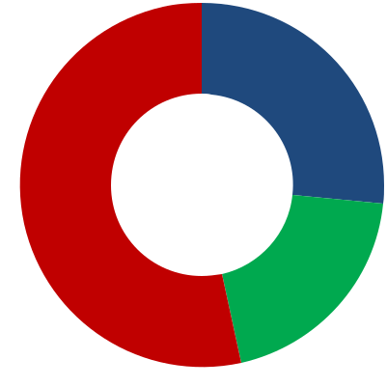

**53%** **FY2021**

**20%**

 San Diego

 Raleigh

 Portland

41

**Ongoing Projects:**

**Improving Portfolio Quality**

**Development**

Built-to-suit business park

development for Grab

**Redevelopment**

25 & 27 Ubi Road 4

iQuest@IBP *(New)*

**Asset Enhancement Initiatives**

The Capricorn *(New)*

The Galen *(New)*

Plaza 8 *(Part of 1, 3 & 5 Changi Business Park Crescent)* 52 & 53 Serangoon North Avenue 4 484-490 & 490-500 Great Western Highway *(New)*

**Country**

Singapore

Singapore

Singapore

Singapore Singapore Singapore Singapore Sydney, Australia

|  |  |
| --- | --- |
| **Estimated** | **Estimated** |
| **Value (S$m)Completion Date(1)** | |
| **181.2** |  |
| 181.2 | 4Q FY2020 |
| **119.3** |  |
| 35.0 | 2Q FY2021 |
| 84.3 | 3Q FY2022 |
| **31.4** |  |
| 6.0 | 1Q FY2020 |
| 7.0 | 1Q FY2020 |
| 8.5 | 1Q FY2020 |
| 8.5 | 2Q FY2020 |
| 1.4 | 2Q FY2020 |

(1) Based on 31 December financial year end. The financial year for 2019 is a nine-month period from 1 April 2019 to 31 December 2019 (FY2019).

42

**Redevelopment *(New)*:**

**iQuest@IBP, Singapore**

|  |  |  |  |
| --- | --- | --- | --- |
|  | This redevelopment is part of the transformation plan to |  |  |
|  | rejuvenate Ascendas Reit’s portfolio of assets within |  |  |
|  | International Business Park (IBP). |  |  |
|  | The property will benefit from enhanced accessibility via |  |  |
|  | the future Jurong Regional Line and enjoy greater |  |  |
|  | vibrancy from its proximity to the Jurong Lake District, |  |  |
|  | which is envisioned to be the largest commercial and |  |  |
|  | regional centre outside the Singapore CBD. |  |  |
| Description | iQuest@IBP will be demolished and rebuild into a new |  |  |
| Business Park building with updated specifications and |  |  |
|  | floor plate of 2,900 sqm. The new building is designed to |  |  |
|  | the highest Green Mark standard of Platinum rating with |  |  |
|  | sustainable features and lush greenery. The building will |  |  |
|  | also include facilities such as a gym, skydeck and |  |  |
|  | foodcourt as well as end of trip facilities to complement |  |  |
|  | the government’s strategy for a car-lite nation. |  |  |
|  | Plot ratio will be maximized, and GFA will increase by |  |  |
|  | approximately 12,000 sqm (after redevelopment 24,641 |  |  |
|  | sqm). |  |  |
|  |  |  |  |
| Property Segment | Business & Science Park |  |  |
| Net Lettable Area | 9,154 sqm (as at 31 Dec 2019), ~19,700 sqm (after |  |  |
| redevelopment) |  |  |
|  |  |  |
| Estimated Cost | S$84.3 m |  |  |
| Estimated | 3Q FY2022 |  |  |
| Completion Date |  |  |
|  |  |  |
|  |  |  |  |
|  | * Artist Impressions (subject to changes) | |  |

Façade View from Jurong Town Hall Road*

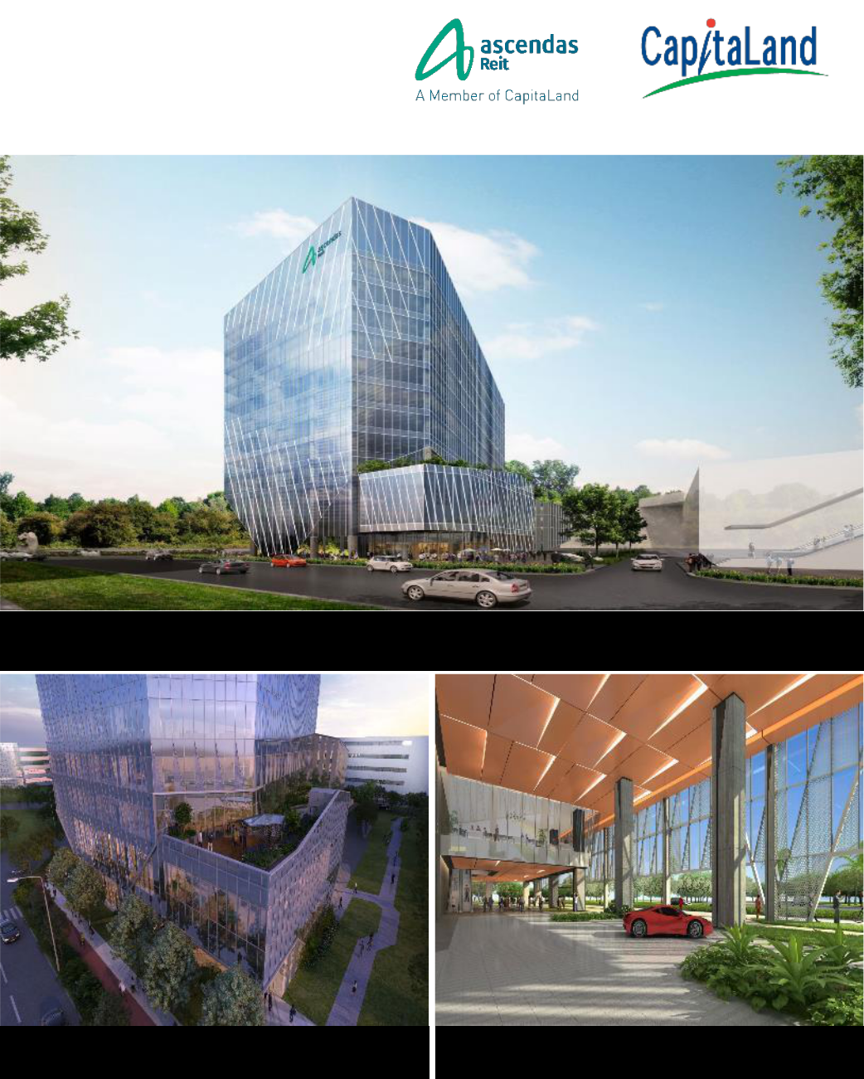

|  |  |
| --- | --- |
| Skydeck and Gym* | Building entrance and driveway* |
|  | 43 |

**Asset Enhancement Initiative *(New)*:**

**The Capricorn, Singapore**

|  |  |  |  |
| --- | --- | --- | --- |
|  | Enhancement works to the building entrance and |  |  |
|  | drop-off point with a new canopy feature |  |  |
| Description | Upgrade to a fully air-conditioned lobby with new |  |  |
| ceiling design and collaborative spaces |  |  |
|  |  |  |
|  | Enhancement works to the lift interior and |  |  |
|  | common corridors |  |  |
| Property Segment | Business & Science Park |  |  |
| Net Lettable Area | 20,543 sqm |  |  |
| Cost | S$6.0 m | Passenger Pick-up/Drop-off Point with Entrance Canopy* |  |
| Completion Date | 1Q FY2020 |  |  |
|  |  |  |  |

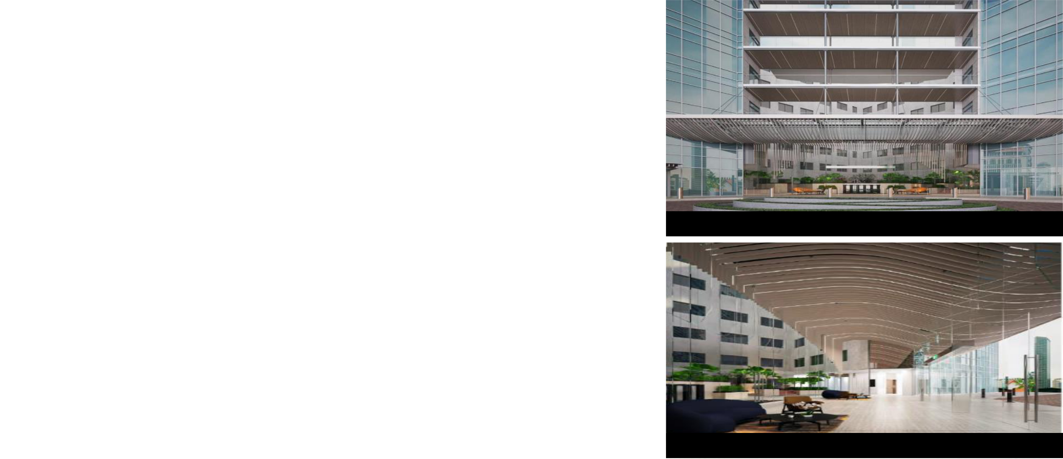

Collaborative Spaces and Common Corridor*

* Artist Impressions 44

**Asset Enhancement Initiative *(New)*:**

**The Galen, Singapore**

|  |  |  |  |
| --- | --- | --- | --- |
|  | Enhancement works to building entrance and lift |  |  |
|  | lobbies, common corridors to create a premium |  |  |
|  | look and feel |  |  |
| Description | Creation of new collaborative spaces and |  |  |
| meeting rooms at the main lobby for tenants’ |  |  |
|  |  |  |
|  | use. |  |  |
|  | Enhancement works to the common area with |  |  |
|  | the introduction of reflection pond |  |  |
| Property Segment | Business & Science Park | Main Lift Lobby and Common Corridor* |  |
| Net Lettable Area | 21,829 sqm |  |
|  |  |
| Cost | S$7.0 m |  |  |
| Completion Date | 2Q FY2020 |  |  |
|  |  |  |  |

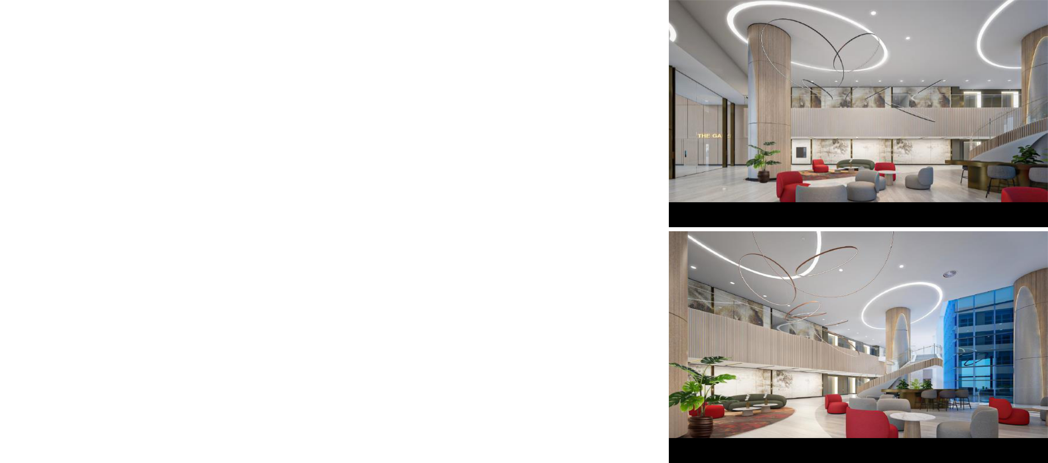

Collaborative Spaces and Meeting Rooms*

* Artist Impressions 45

**Asset Enhancement Initiative *(New)*:**

**484-490 & 490-500 Great Western Highway, Sydney, Australia**

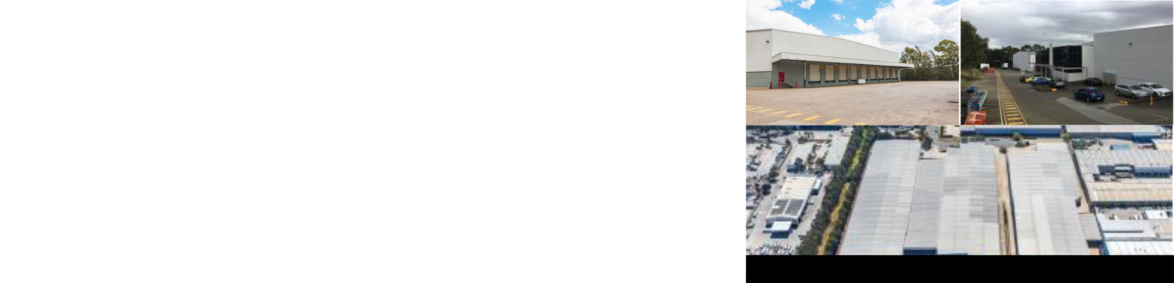

|  |  |  |
| --- | --- | --- |
|  | Asset enhancement works include external |  |
| Description | redecoration of the warehouses, internal |  |
| refurbishment and new LED lighting & translucent |  |
|  |  |
|  | sheeting |  |
| Property Segment | Logistics |  |
|  | Excluding decommissioned space |  |
| Net Lettable Area | 484 Great Western Highway: 7,287 sqm |  |
|  | 494 Great Western Highway: 12,775 sqm |  |
| Cost | A$1.5m (S$1.4m) |  |
| Estimated Completion Date | 2Q FY2020 |  |
|  |  |  |

Building façade (Before)

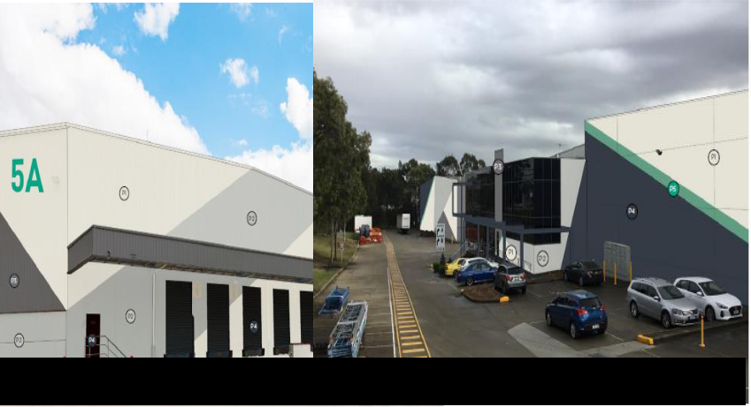

1. S$ amount based on exchange rate of A$1.00: S$0.92791 as at 31 Dec 2019
   * Artist Impressions

Building façade (After)*

46

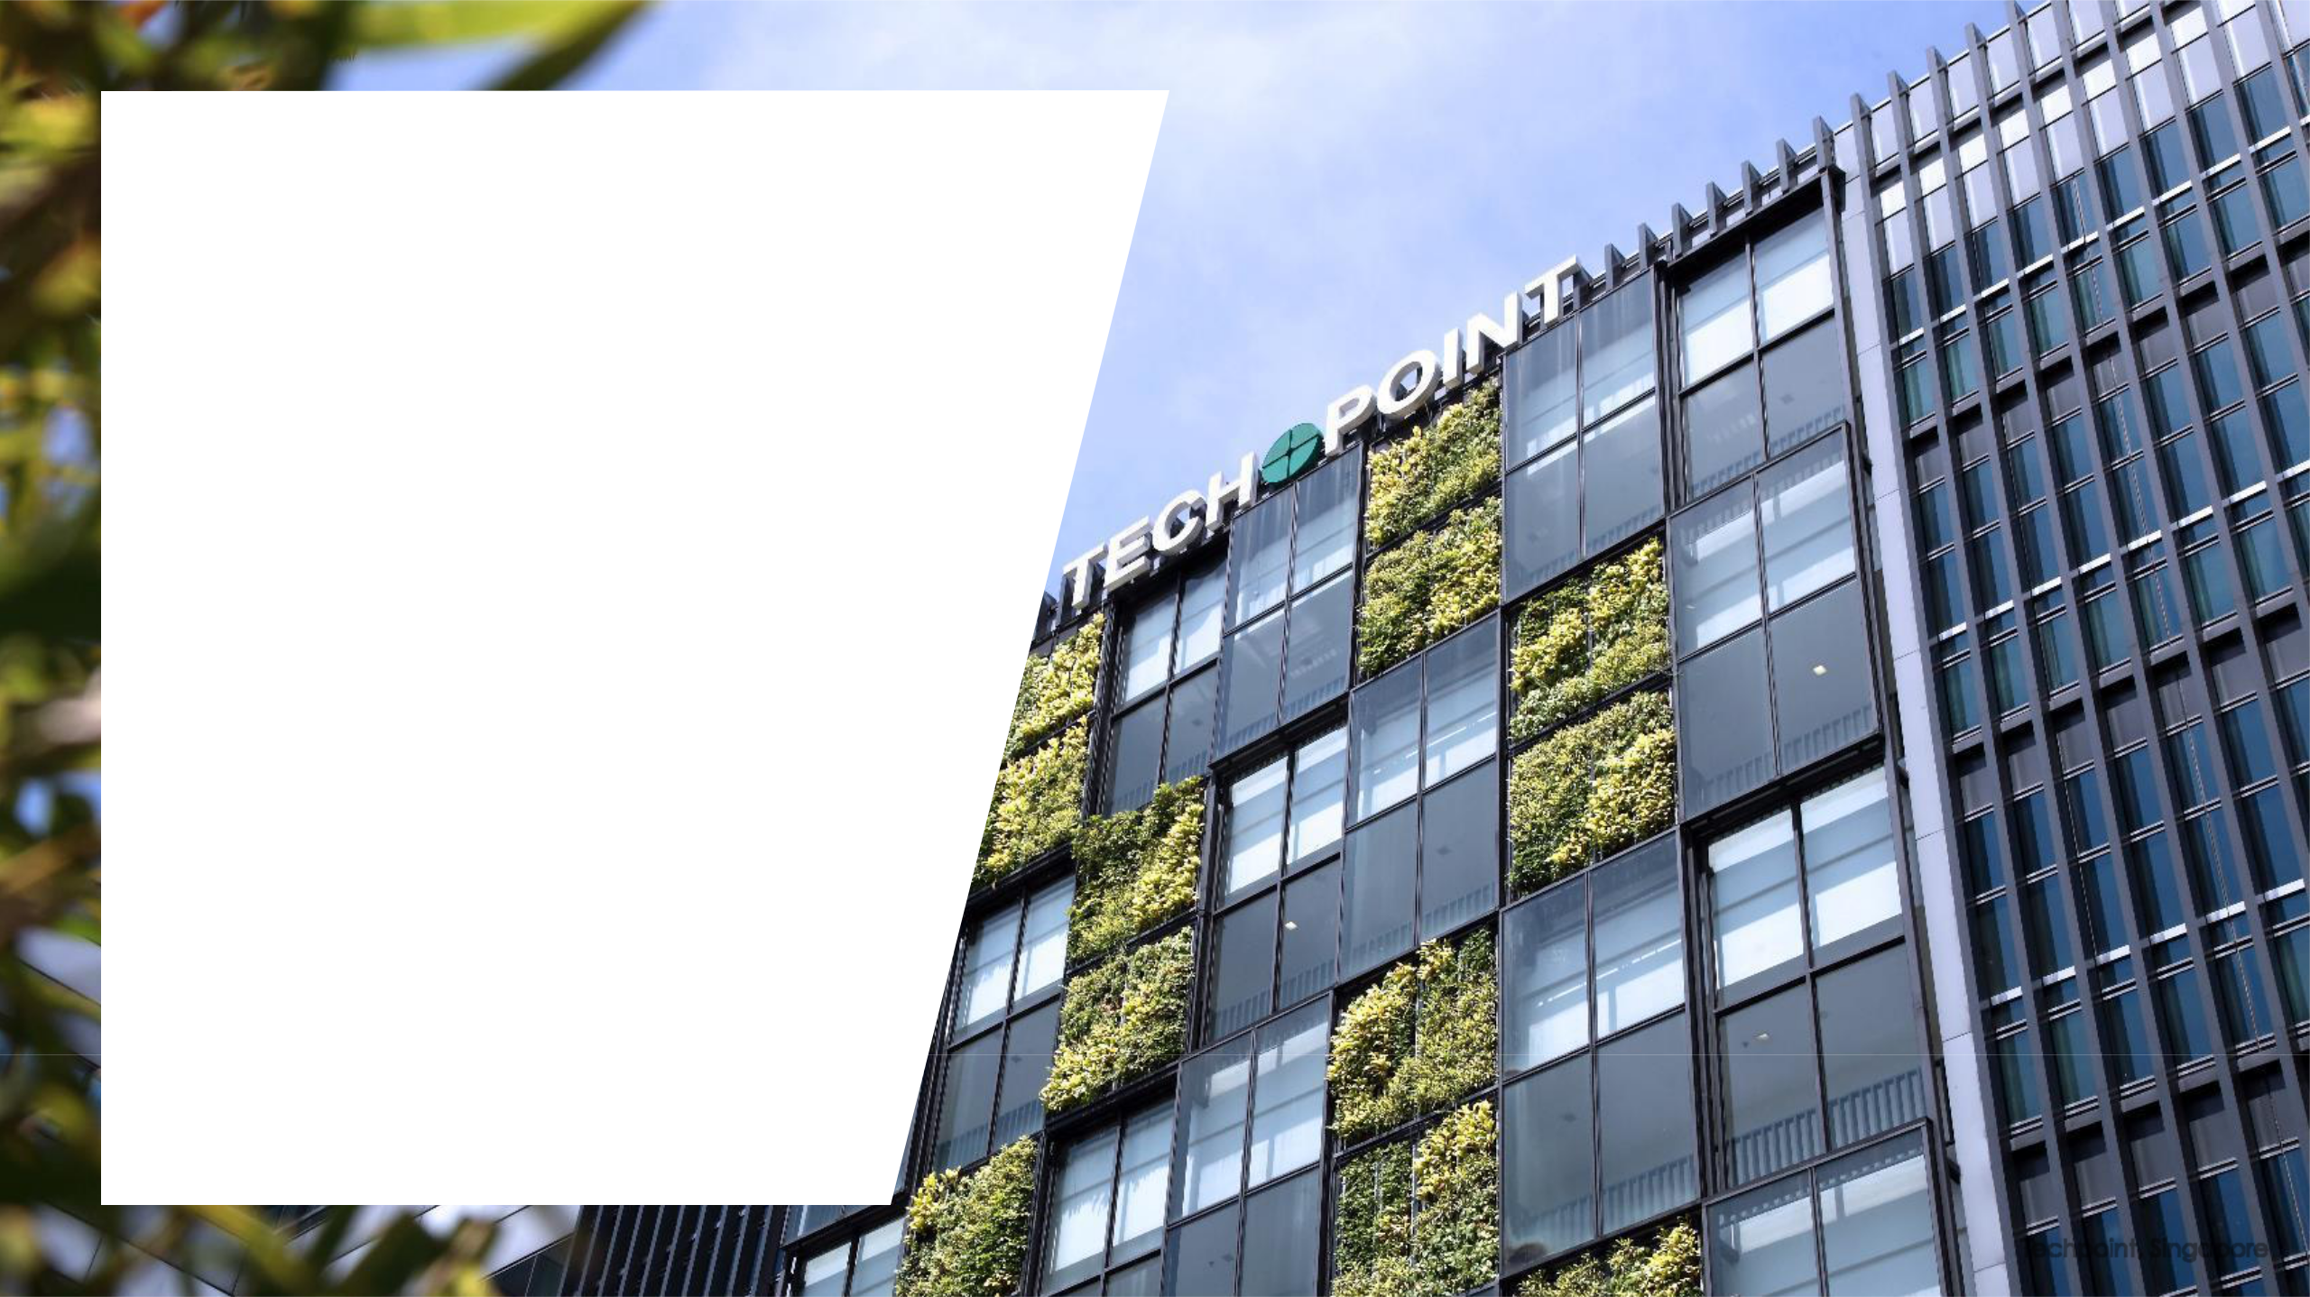

**Portfolio Resilience**

Techpoint, Singapore

47

**Well Diversified Portfolio**

**By Value of Investment Properties**

**Australia, 12%**

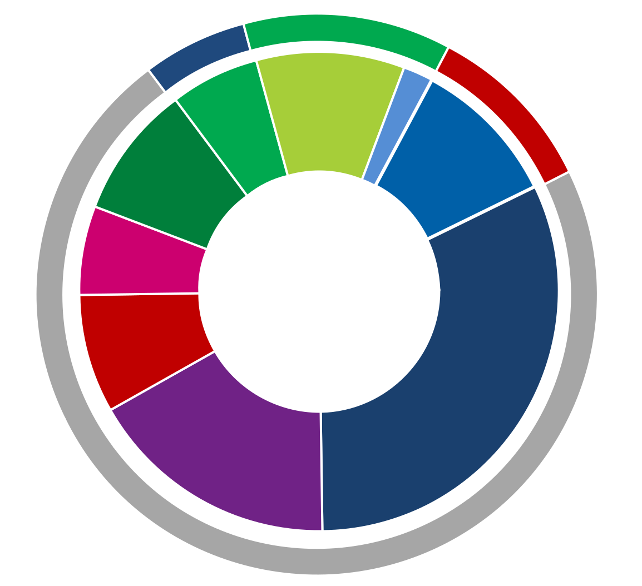

**United Kingdom,**

|  |  |  |  |  |  |  |
| --- | --- | --- | --- | --- | --- | --- |
| ▪ As at 31 Dec 2019, total investment properties | | **6%** |  |  | **United States,** |  |
| stood at **S$12.84 b** | |  |  | **Logistics and** | **10%** |  |
| **Logistics and** | | **Distribution** | **Suburban** |  |
|  |  | **Centres** | **Offices** |  |
| ▪ Singapore portfolio: ***S$9.16 b*** | |  | **Distribution** |  |
|  | **Australia** | **Australia** |  |
| **Centres United** | |  |
| ▪ | Australia portfolio: ***S$1.57 b*** | **Logistics &** | **Kingdom** | **10%** | **2%** |  |
| **Distribution** | **6%** |  |  |  |
| ▪ United Kingdom portfolio: ***S$0.80 b*** | | **Centres** |  |  | **Business Park US** |  |
| **Singapore** |  |  | **10%** |  |
| ▪ United States portfolio: ***S$1.31 b*** | | **9%** |  |  |  |  |
| **Integrated** |  |  |  |  |
|  |  | **Development,** | **Total Investment** | | |  |
|  |  | **Amenities &** |  |
|  |  |  |  |  |  |
|  |  | **Retail** | **Properties** | |  |  |
| ▪ Diversified across | | **6%** |  |  |
| **Light industrial** | **S$12.84 b** | |  |  |
| ▪ Business & Science Park/ Suburban office: **44%** | | **and Flatted** |  |  |
|  |  |  |  |
| **Factories** |  |  |  |  |
| ▪ | Industrial: **31%** | **8%** |  |  | **Business &** |  |
|  |  |  |  |
|  |  |  | **Science Parks** |  |
| ▪ Logistics & Distribution Centre: **25%** | |  | **High-** |  | **32%** |  |
|  |  |  |  |

|  |  |  |
| --- | --- | --- |
|  | **Specifications** |  |
|  | **Industrial and** |  |
|  | **Data Centres** |  |
| **Singapore, 72%** | **17%** |  |
|  |  |
| Notes: |  |  |
| Multi-tenant buildings account for 71.0% of Ascendas Reit’s portfolio by asset value as at 31 Dec 2019. |  |  |
| About 65.1% of Logistics & Distribution Centres in Singapore (by gross floor area) are multi-storey facilities with vehicular ramp access. |  |  |
| Within Hi-Specs Industrial, there are 3 data centres (4.2% of portfolio), of which 2 are single-tenant buildings. |  |  |
| Within Light Industrial, there are 2 multi-tenant flatted factories (2.6% of portfolio). | 48 |  |
|  |  |

**Customers’ Industry Diversification**

**(By Monthly Gross Revenue)**

* Well-diversified customer base across more than 20 industries



|  |  |
| --- | --- |
| Engineering |  |
| Logistics & Supply Chain Management |  |
| Biomedical Sciences |  |
| Information & Communications Technology |  |
| Electronics |  |
| Financial Services |  |
| Government |  |
| Data centres |  |
| Distributors & Trading Company |  |
| Retail |  |
| Food |  |
| Professional Services |  |
| Chemical |  |
| Media | 1.3% |
| Textile & Garments | 0.9% |
| Energy/Utilities | 0.8% |
| Education | 0.7% |
| e-Commerce | 0.5% |
| Hospitality & Leisure | 0.5% |
| FMCG | 0.5% |
| Real Estate | 0.3% |
| Agriculture | 0.1% |
| IO/NGOs/NPOs | 0.1% |
| Conglomerate | 0.04% |
| Natural Resources | 0.03% |
|  |  |

|  |  |  |  |  |
| --- | --- | --- | --- | --- |
|  |  |  | 13.2% |  |
|  |  |  | 12.2% |  |
|  |  |  | 11.3% |  |
|  |  |  | 9.7% |  |
|  |  |  | 8.5% |  |
|  |  |  | 8.4% |  |
|  |  |  | 5.9% |  |
|  |  |  | 5.6% |  |
|  |  |  | 5.4% |  |
|  |  | 4.9% | **More than** |  |
|  | 3.6% |  |  |
|  |  |  |  |
| 3.0% |  |  | **20 industries** |  |
| 2.6% |  |  |  |

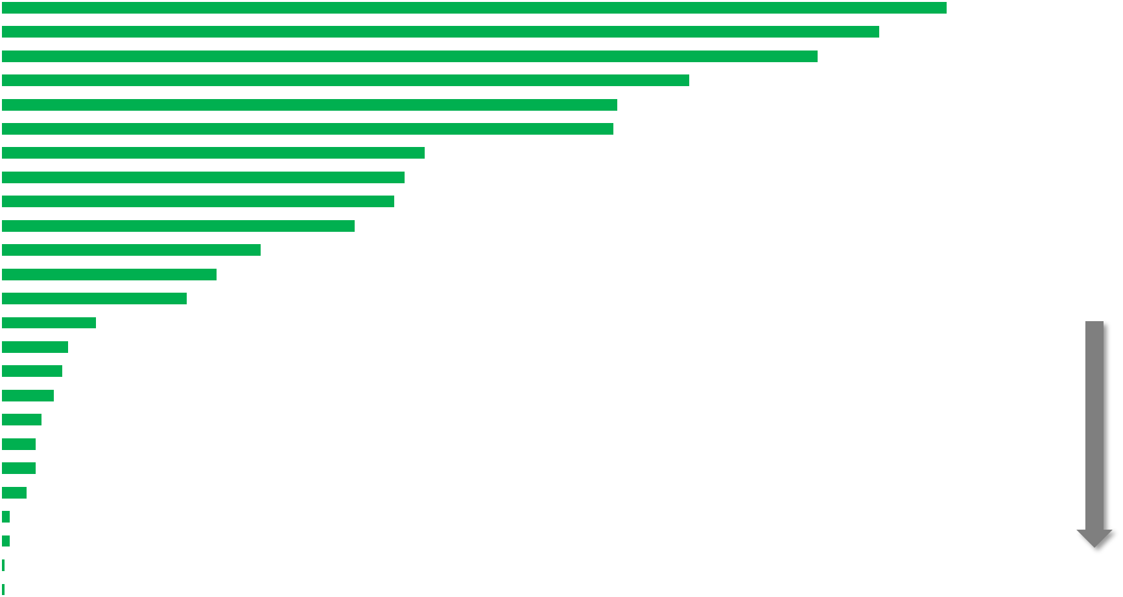

|  |  |  |
| --- | --- | --- |
| Note: Customers’ Industry classifications have been updated to better reflect the organisation’s primary industry sector. Previous industry classifications were based on the | 49 |  |
| Singapore Standard Industrial Classification (SSIC) which may be outdated due to changes in business activities. |  |
|  |  |

**Quality and Diversified Customer Base**

* Total customer base of around 1,490 tenants
* Top 10 customers (as at 31 Dec 2019) account for about 17.9% of monthly portfolio gross revenue.
* On a portfolio basis, weighted average security deposit is about 4.7 months of rental income

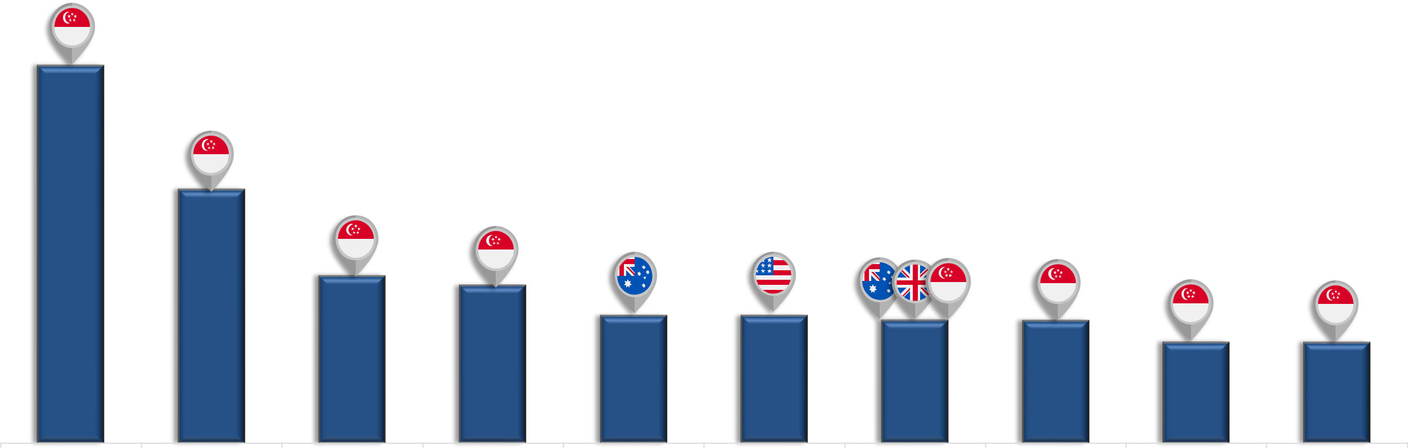

4.1%

 geographical location(s) of property

2.7%

1.8% 1.7%

1.4% 1.4% 1.3% 1.3%

1.1% 1.1%

|  |  |  |  |  |  |  |  |  |  |  |
| --- | --- | --- | --- | --- | --- | --- | --- | --- | --- | --- |
| **Singapore** | **DSO National** | **Citibank, N.A** | **DBS Bank Ltd** | **Wesfarmers Group** | **Carefusion** | **Ceva Logistics S Pte** | **JPMorgan Chase** | **Siemens Pte Ltd** | **A*STAR Research** |  |
| **Telecommunications** | **Laboratories** |  |  |  | **Manufacturing, LLC** | **Ltd** | **Bank, N.A.** |  | **Entities** |  |
| **Ltd** |  |  |  |  |  |  |  |  | 50 |  |
|  |  |  |  |  |  |  |  |  |  |

**Diversified Portfolio**

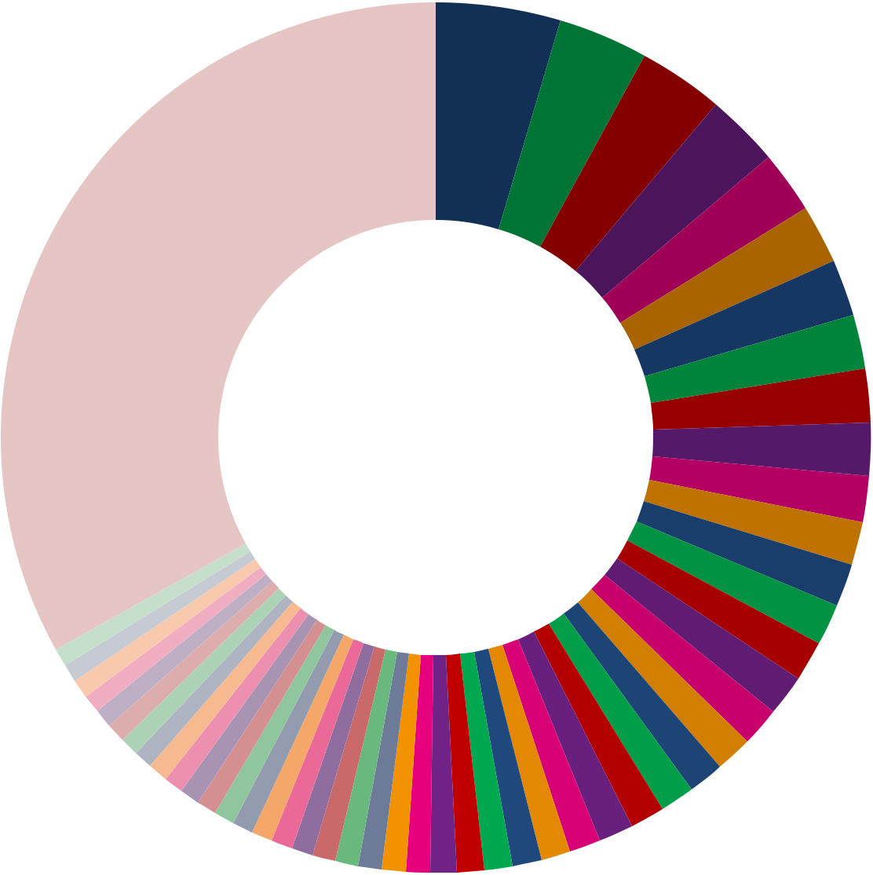

**No single property**

**accounts for more than**

**4.6% of Ascendas Reit’s**

**monthly gross revenue**

|  |  |  |  |  |
| --- | --- | --- | --- | --- |
|  | Aperia, 4.6% |  | ONE @ Changi City, 3.3% |  |
|  |  |  |
|  |  |  |
|  | 12, 14 & 16 Science Park Drive, 3.2% |  | 1, 3 & 5 Changi Business Park Crescent, 2.7% |  |
|  |  |  |
|  |  |  |
|  | Kim Chuan Telecommunication Complex, 2.3% |  | Pioneer Hub, 2.2% |  |
|  |  |  |
|  |  |  |
|  | Neuros & Immunos, 2.1% |  | TelePark, 2.0% |  |
|  |  |  |
|  |  |  |
|  | Nucleous, 2.0% |  | The Kendall, 1.9% |  |
|  |  |  |
|  |  |  |
|  | TechPlace II, 1.7% |  | Nexus@One North, 1.6% |  |
|  |  |  |
|  |  |  |
|  | 40 Penjuru Lane, 1.6% |  | Techview, 1.5% |  |
|  |  |  |
|  |  |  |
|  | TechPoint, 1.5% |  | The Aries, Sparkle & Gemini, 1.5% |  |
|  |  |  |
|  |  |  |
|  | Corporation Place, 1.5% |  | 80 Bendemeer Road, 1.4% |  |
|  |  |  |
|  |  |  |
|  | DBS Asia Hub (Phase I & II), 1.3% |  | 31 International Business Park, 1.3% |  |
|  |  |  |
|  |  |  |
|  | Siemens Centre, 1.3% |  | TechPlace I, 1.3% |  |
|  |  |  |
|  |  |  |
|  | Techlink, 1.2% |  | FoodAxis @ Senoko, 1.1% |  |
|  |  |  |
|  |  |  |
|  | 10 Toh Guan Road, 1.1% |  | 10020 Pacific Mesa Boulevard, 1.0% |  |
|  |  |  |
|  |  |  |
|  | Cintech III & IV, 1.0% |  | Infineon Building, 1.0% |  |
|  |  |  |
|  |  |  |
|  | Nordic European Centre, 0.9% |  | The Capricorn, 0.9% |  |
|  |  |  |
|  |  |  |
|  | HansaPoint @ CBP, 0.9% |  | The Galen, 0.9% |  |
|  |  |  |
|  |  |  |
|  | Giant Hypermart, 0.8% |  | Perimeter Three, 0.8% |  |
|  |  |  |
|  |  |  |
|  | 5200 East & West Paramount Parkway, 0.8% |  | Perimeter One, 0.8% |  |
|  |  |  |
|  |  |  |
|  | 138 Depot Road, 0.8% |  | 19 & 21 Pandan Avenue, 0.7% |  |
|  |  |  |
|  |  |  |
|  | AkzoNobel House, 0.7% |  | The Alpha, 0.7% |  |
|  |  |  |
|  |  |  |
|  | 5005 & 5010 Wateridge, 0.7% |  | Courts Megastore, 0.7% |  |
|  |  |  |
|  |  |  |
|  | LogisTech, 0.7% |  | 7 Grevillea Street, 0.7% |  |
|  |  |  |
|  |  |  |
|  | 21 Jalan Buroh, 0.7% |  | Changi Logistics Centre, 0.7% |  |
|  |  |  |
|  |  |  |
|  | Acer Building, 0.7% |  | Perimeter Two, 0.7% |  |
|  |  |  |
|  |  |  |
|  | Pacific Tech Centre, 0.7% |  | Perimeter Four, 0.7% |  |
|  |  |  |
|  |  |  |
|  | Others, 33.1% | 51 | |  |
|  |  |
|  |  |
|  |  |  |



**A More Sustainable Portfolio**



**BCA GREEN MARK AWARD (PLATINUM)**

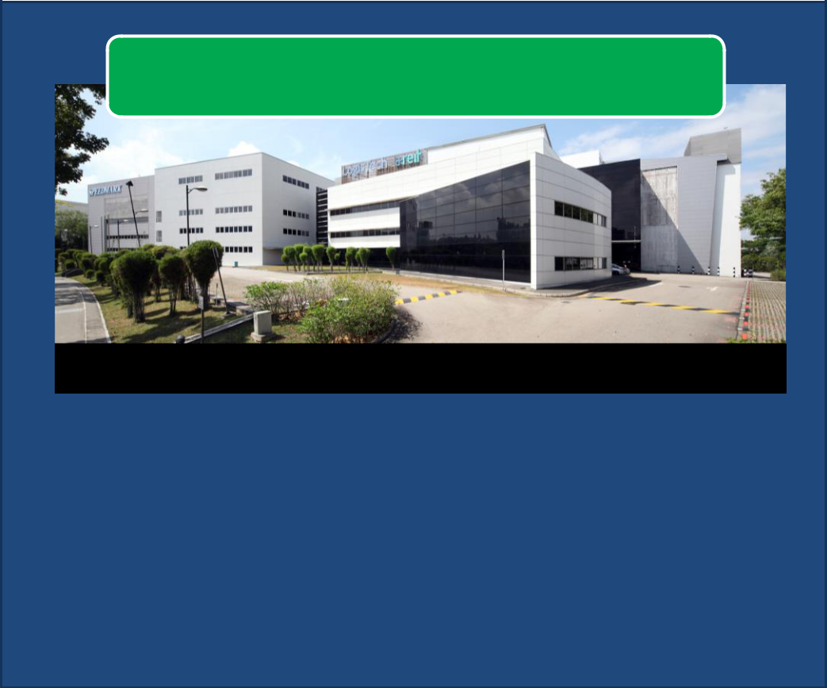

**(SUPER LOW ENERGY)**

LogisTech, Singapore

In January 2020, LogisTech (logistics property) was recognised by the Building and Construction Authority (BCA) for being

* 1. best-in-class energy efficient building (>60% energy savings over 2005 building codes.)

1. As at 31 March 2019, Ascendas Reit had 22 BCA Green Mark Properties.

Ascendas Reit is committed to minimising our environmental impact.

As at 31 Jan 2020, we have **35 BCA Green**

**Mark Properties(1)** in Singapore.

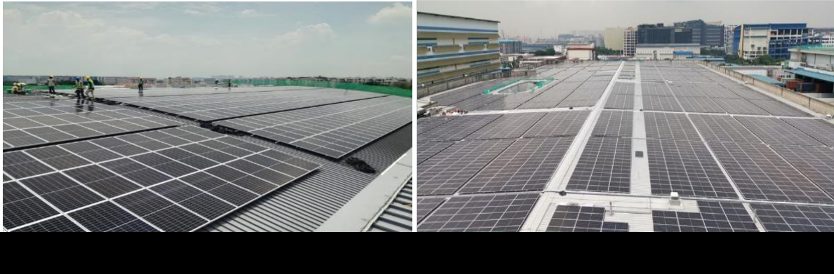

Solar panel installations at LogisTech and 40 Penjuru, Singapore

The installation of more than 22,000 solar panels on the roof of six Ascendas Reit properties were completed as at 31 Jan 2020. The installation will generate more than 10,000 megawatt hours of energy annually.

52

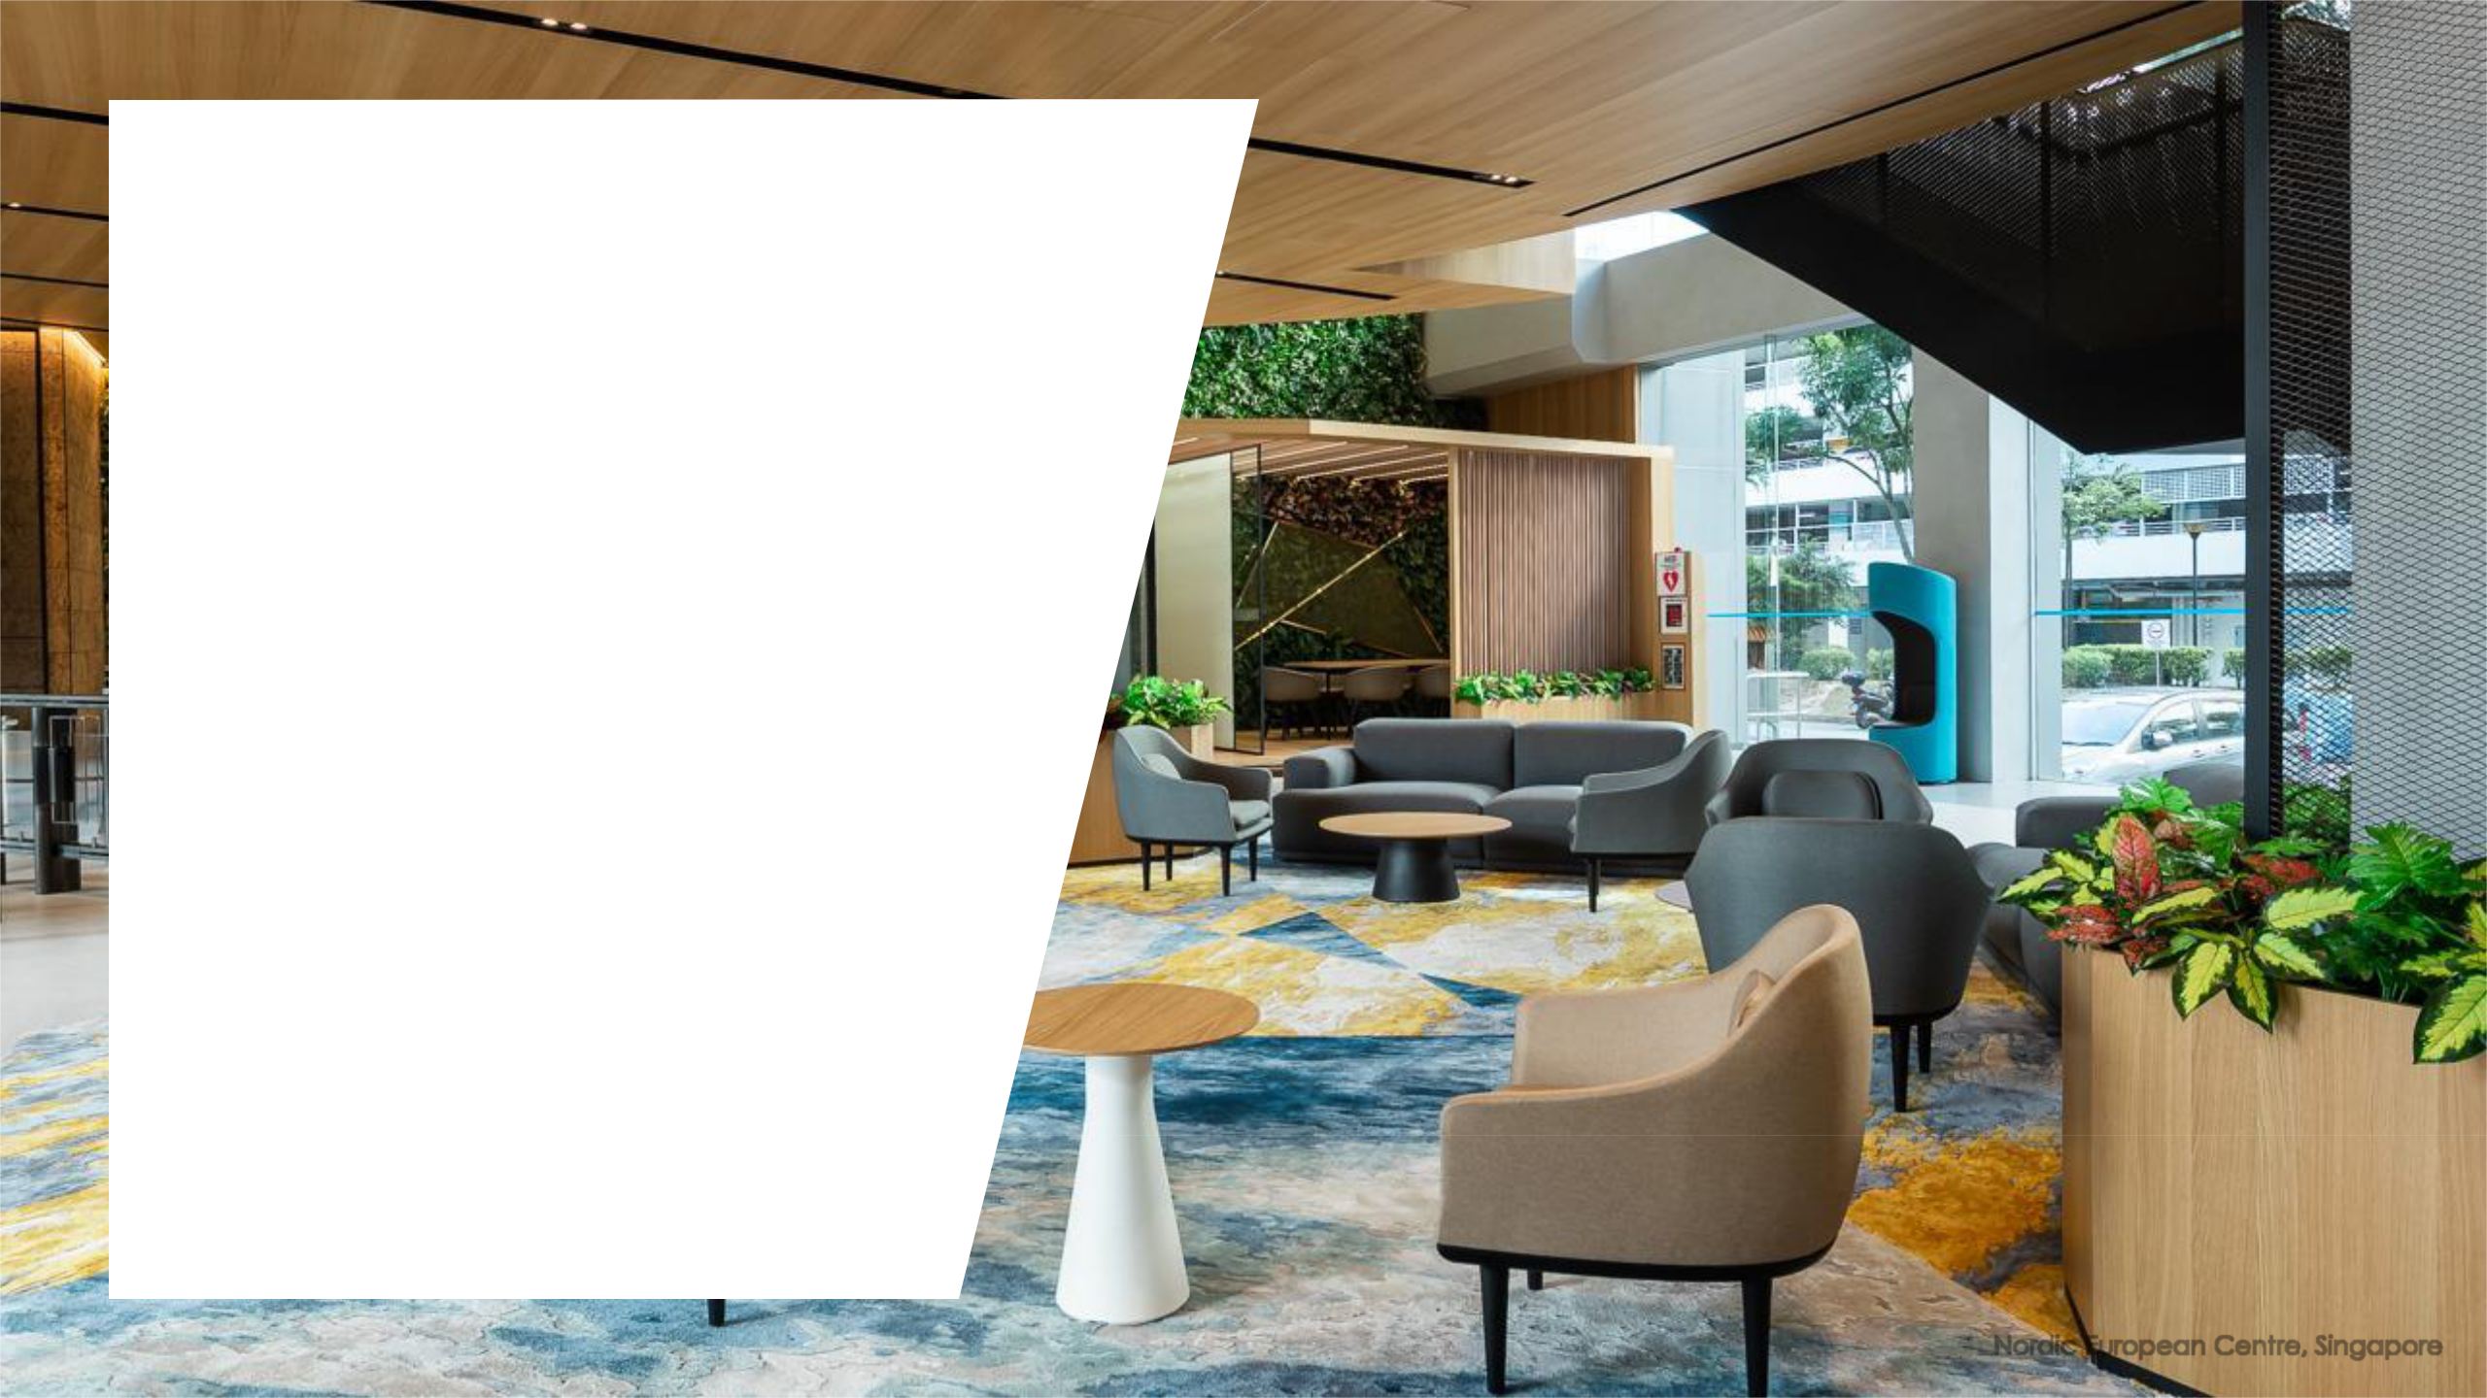

**Market Outlook**

Nordic European Centre, Singapore

53

**Market Outlook**

* In 2019, global growth was dampened by trade tensions and weak business sentiments. Although several economists expect global growth to recover modestly in 2020, downside risks from trade and economic policy uncertainties remain.
* The Singapore economy grew 0.7% y-o-y in 2019 and is expected to grow between 0.5% to 2.5% in 2020. (MTI)
  + An additional 2.2 m sqm of new industrial space is expected to complete in 2020, representing 4.4% of the total stock of 49.6 million sqm as at 31 December 2019.
  + Companies are expected to remain conservative with their business and expansion plans in view of the lingering economic uncertainties. Rental growth and demand for industrial space may remain subdued.
* Australia’s economy grew by 1.7% y-o-y in 3Q FY2019 and is expected to grow by 2.2% in 2020 (Bloomberg). To reduce unemployment and achieve its inflation target over time, the Reserve Bank of Australia lowered its cash rate three times in 2019 from 1.5% to 0.75% (RBA)
  + Ascendas Reit’s Australian properties continue to deliver stable performance due to their good locations, long WALE of 4.4 years and average rent escalations of approximately 3% per annum
* UK’s economy rose by 1.1% y-o-y in 3Q 2019 and is forecasted to grow by 1.1% y-o-y in 2020 (Bloomberg)
  + The high e-commerce penetration rate (21% of retail sales) (source: Office for National Statistics) in the UK is expected to continue to benefit the logistics sector. Ascendas Reit’s UK portfolio has a long WALE of 8.8 years, which will help to mitigate the on-going uncertainties surrounding the future of the UK post Brexit.
* The US economy is in its 11th consecutive year of growth. In 3Q 2019, the economy recorded a growth of 2.1% y-o-y and is expected to grow by 1.8% y-o-y in 2020.
  + The US properties are well-positioned to benefit from the fast-growing technology and healthcare sectors. The strength of the US portfolio is also underpinned by its WALE of 4.1 years, and the high proportion of leases with rent escalations of between 2.5% to 4.0% per annum.
* The stability of Ascendas Reit’s performance is underpinned by its large and diversified portfolio with a strong tenant base. The Manager will continue to strengthen Ascendas Reit’s presence across its four developed markets to optimise portfolio

|  |  |
| --- | --- |
| returns. | 54 |

**Additional Information**

1. Historical Quarterly Results
2. Ascendas Reit’s Singapore Occupancy vs Industrial Average
3. Singapore Industrial Property Market
4. Singapore New Supply

55

**Historical Quarterly Results**

**Financial**

**Highlights**

**(S$ m)**

Gross Revenue

Net Property Income

Total Amount Available for Distribution

No. of Units in Issue (m)

Distribution Per Unit (cents)

|  |  |  |  |  |  |  |  |  |
| --- | --- | --- | --- | --- | --- | --- | --- | --- |
|  |  | **FY18/19** |  |  |  | **FY2019** | |  |
|  |  |  |  |  |  |  |  |  |
| **1Q** | **2Q** | **3Q** | **4Q** | **Total** | **1Q** | **2Q** | **3Q** | **Total\*** |
|  |  |  |  |  |  |  |  |  |
| 217 | 218 | 226 | 225 | 886 | 230 | 230 | 239 | 699 |
| 159 | 159 | 168 | 164 | 650 | 178 | 178 | 182 | 538 |
| 117 | 115 | 124 | 130 | 486 | 124 | 124 | 127 | 375 |
| 2,930 | 3,108 | 3,111 | 3,111 | 3,111 | 3,113 | 3,113 | 3,613 | 3,613 |
| 4.002 | 3.887 | 3.998 | 4.148 | 16.035 | 4.005 | 3.978 | 3.507 | 11.490 |
|  |  |  |  |  |  |  |  |  |

* Ascendas Reit changed its financial year end from 31 March to 31 December. Therefore, FY2019 is a nine-month period from 1 April 2019 to 31 December 2019. Please refer to the announcement dated [24 July 2019](https://ir.ascendas-reit.com/newsroom/20190724_174002_A17U_YL5JVMJEY585WZZZ.1.pdf) for more information.

56

**Ascendas Reit’s Singapore**

**Occupancy vs Industrial Average**

|  |
| --- |
| **Occupancy Rate** |

100%

95%

90%

85%

80%

75%

70%

65%

60%

55%

50%

90.3%

|  |  |  |  |  |  |  |  |  |  |  |  |  |  |  |  |  |
| --- | --- | --- | --- | --- | --- | --- | --- | --- | --- | --- | --- | --- | --- | --- | --- | --- |
|  |  | 86.2% |  |  | 87.5% | |  |  | 87.5% | |  |  |  | 88.0% |  |  |
|  |  |  |  |  |  |  |  |  |  |  |
|  |  |  |  |  |  |  |  |  |  |  |  |
|  | 83.8% |  |  | 85.7% |  |  |  | 85.6% |  |  |  |  |  |  |  |
|  |  |  |  |  |  |  |  |  |  |  |  |  |  |
|  |  |  |  |  |  |  |  |  |  |  |  |  |  |  |  |  |
|  |  |  |  |  |  |  |  |  |  |  |  |  |  |  |  |  |
|  |  |  |  |  |  |  |  |  |  |  |  |  |  |  |  |  |



Business and Science Park High-Specifications Industrial Light Industrial Logistics

|  |  |  |  |
| --- | --- | --- | --- |
| Ascendas Reit |  | JTC Statistics |  |
|  |  |
|  |  |

|  |  |  |
| --- | --- | --- |
| Source : |  |  |
| Ascendas Reit’s Singapore portfolio as at 31 Dec 2019. Market: JTC statistics as at 23 Jan 2020 (4Q 2019). |  |  |
| JTC statistics do not breakdown High-Specifications Industrial and Light Industrial, ie they are treated as one category with occupancy of 87.5% | 57 |  |
|  |  |



**Average Market Rents (Singapore)**

**by Segment**

|  |  |  |  |  |  |  |  |  |  |  |  |  |  |  |  |  |  |  |  |  |  |
| --- | --- | --- | --- | --- | --- | --- | --- | --- | --- | --- | --- | --- | --- | --- | --- | --- | --- | --- | --- | --- | --- |
| 120.00 |  |  |  |  |  |  |  |  | Industrial Rental Index | | |  |  |  |  |  | 3Q2019: | | | **4Q2019:** |  |
|  |  |  |  |  |  |  |  |  |  |  |  |  |  |  |
| 100.00 |  |  |  |  |  |  |  |  |  |  |  |  |  |  |  |  |  | 91.0 |  | **91.0** |  |
| 80.00 |  |  |  |  |  |  |  |  |  |  |  |  |  |  |  |  | 1Q2019: |  | 2Q2019: | |  |
|  |  |  |  |  |  |  |  |  |  |  |  |  |  |  |  |  | 90.9 |  |  | 91.0 |  |
| 60.00 |  |  |  |  |  |  |  |  |  |  |  |  |  |  |  |  |  |  |  |  |  |
| 40.00 |  |  |  |  |  |  |  |  |  |  |  |  |  |  |  |  |  |  |  |  |  |
| 20.00 |  |  |  |  |  |  |  |  |  |  |  |  |  |  |  |  |  |  |  |  |  |
| 0.00 |  |  |  |  |  |  |  |  |  |  |  |  |  |  |  |  |  |  |  |  |  |
| 2000 | 2001 | 2002 | 2003 | 2004 | 2005 | 2006 | 2007 | 2008 | 2009 | 2010 | 2011 | 2012 | 2013 | 2014 | 2015 | 2016 | 2017 | 2018 |  | 2019 |  |

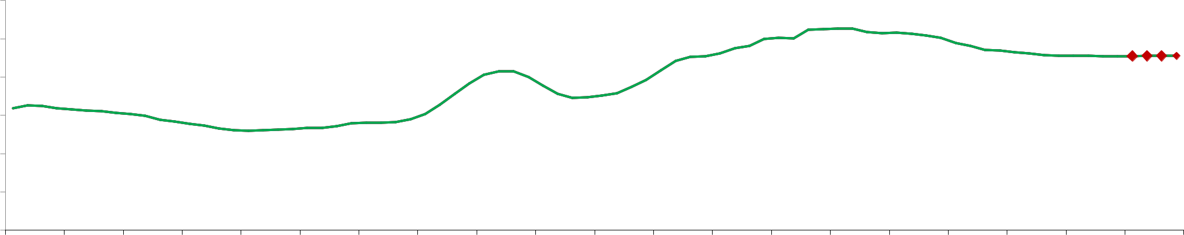

*Source : JTC’s Fourth Quarter Market Report*

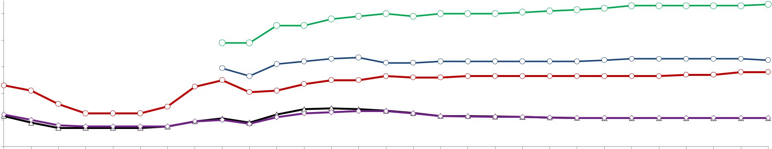

|  |  |  |  |  |  |  |  |  |  |  |  |  |  |  |  |  |  |  |  |  |  |  |  |  |  |  |  |  |  |  |
| --- | --- | --- | --- | --- | --- | --- | --- | --- | --- | --- | --- | --- | --- | --- | --- | --- | --- | --- | --- | --- | --- | --- | --- | --- | --- | --- | --- | --- | --- | --- |
|  | $5.5 |  |  |  |  |  |  |  |  |  |  |  |  |  |  |  |  |  |  |  |  |  |  | Business Park (City Fringe) : $5.85 psfpm | | | | | |  |
|  |  |  |  |  |  |  |  |  |  |  |  |  |  |  |  |  |  |  |  |  |  |  |  |  |
|  | $4.5 |  |  |  |  |  |  |  |  |  |  |  |  |  |  |  |  |  |  |  |  |  | Business Park (Rest of Island) : $3.75 psfpm | | | | | | |  |
|  |  |  |  |  |  |  |  |  |  |  |  |  |  |  |  |  |  |  |  |  |  |  |  |
| ($/psfpm) | $3.5 |  |  |  |  |  |  |  |  |  |  |  |  |  |  |  |  |  |  |  |  |  |  |  |  |  |  |  |  |  |
| $2.5 |  |  |  |  |  |  |  |  |  |  |  |  |  |  |  |  |  |  |  |  |  |  |  | High-Specifications : $3.30 psfpm | | | | |  |
|  |  |  |  |  |  |  |  |  |  |  |  |  |  |  |  |  |  |  |  |  |  |  |  |  |  |  |  |  |
| Rental |  |  |  |  |  |  |  |  |  |  |  |  |  |  |  |  |  |  |  |  |  |  |  |  | Light Industrial : $1.57 psfpm | | | | |  |
| $1.5 |  |  |  |  |  |  |  |  |  |  |  |  |  |  |  |  |  |  |  |  |  |  |  |  |  |  |  |  |  |
|  |  |  |  |  |  |  |  |  |  |  |  |  |  |  |  |  |  |  |  |  |  |  |  |  |  | Logistics : $1.58 psfpm | | | |  |
|  | $0.5 |  |  |  |  |  |  |  |  |  |  |  |  |  |  |  |  |  |  |  |  |  |  |  |  |  |  |  |  |  |
|  | 2000 | 2001 | 2002 | 2003 | 2004 | 2005 | 2006 | 2007 | 2008 | 2009 | 2010 | 2011 | 2012 | 2013 | 2014 | 2015 | 2016 | 2017Q1 | 2017Q2 | 2017Q3 | 2017Q4 | 2018Q1 | 2018Q2 | 2018Q3 | 2018Q4 | 2019Q1 | 2019Q2 | 2019Q3 | 2019Q4 |  |
|  |  |  | Business Park (City Fringe) | | | |  |  | Business Park (Rest of Island) | | | | |  |  | High-Specifications | | |  |  |  | Light Industrial | | |  |  | Logistics |  |  |  |



|  |  |
| --- | --- |
| Source : | 58 |
| CBRE Market View Report Q4 2019 for Business Park (City Fringe), Business Park (Rest of Island), High-Specifications, Light Industrial and Logistics. |  |

**Singapore Industrial Market:**

**New Supply**

* Potential new supply of about 2.9 m sqm (~5.8% of existing stock) over next 3 years, of which 47% are pre-committed
* Island-wide occupancy was 89.2% as at 31 Dec 19 (vs. 89.3% as at 30 Sep 19)

|  |  |  |  |  |  |  |  |  |
| --- | --- | --- | --- | --- | --- | --- | --- | --- |
|  |  |  |  |  | **New** | **Existing Supply** | **% of New/** |  |
|  | **Sector ('000 sqm)** | **2020** | **2021** | **2022** | **Supply** |  |
|  | **(Total)** | **Existing supply** |  |
|  |  |  |  |  | **(Total)** |  |
|  |  |  |  |  |  |  |  |
|  |  |  |  |  |  |  |  |  |
|  | **Business & Science Park** | **170** | **41** | **0** | **229** | 2,199 | 10.4% |  |
|  | % of Pre-committed (est) | 56% | 100% | 0% | 67% |  |
|  |  |  |  |
|  | **High-Specifications Industrial** | **141** | **37** | **0** | **178** |  |  |  |
|  | % of Pre-committed (est) | 100% | 100% | 0% | 100% | 36,452 | 6.0% |  |
|  | **Light Industrial** | **1,213** | **508** | **428** | **2,000** |  |
|  |  |  |  |
|  | % of Pre-committed (est) | 32% | 55% | 0% | 46% |  |  |  |
|  | **Logistics & Distribution Centres** | **277** | **141** | **100** | **452** | 10,981 | 4.1% |  |
|  | % of Pre-committed (est) | 20% | 11% | 100% | 23% |  |
|  |  |  |  |
|  |  |  |  |  |  |  |  |  |
|  | **Total** | **1,800** | **728** | **528** | **2,860** | **49,632** | **5.80%** |  |
|  |  |  |  |  |  |  |  |  |
|  | % Pre-committed (est) | **38%** | 51% | 19% | 47% | - |  |  |
| Note: | |  |  |  |  |  |  |  |
| Excludes projects under 7,000 sqm. Based on gross floor area | | |  |  |  |  |  |  |
| Source: | |  |  |  |  |  | 59 |  |
| URA Realis & Ascendas Reit internal research | |  |  |  |  |  |  |

**Singapore Business & Science Parks:**

**New Supply**

|  |  |  |  |  |  |
| --- | --- | --- | --- | --- | --- |
| **Expected** | **Location** | **Developer** | **GFA (sqm)** | **% Pre-committed** |  |
| **Completion** | **(Estimated)** |  |
|  |  |  |  |
|  |  |  |  |  |  |
| 2020 | One-north Crescent | Snakepit-BP LLP | 16,320 | 100% |  |
| 2020 | Biopolis Road | Wilmar International | 16,580 | 100% |  |
| Limited |  |
|  |  |  |  |  |
| 2020 | Cleantech Heights | PBA Innovation Centre | 26,490 | 100% |  |
| Pte Ltd |  |
|  |  |  |  |  |
| 2020 | One-north Avenue | Ascendas Reit | 36,240 | 100% |  |
| 2020 | Cleantech Loop | JTC Corporation | 74,420 | 0% |  |
|  |  |  |  |  |  |
| 2021 | Cleantech Loop | Surbana Jurong | 41,350 | 0% |  |
|  |  |  |  |  |  |
|  |  |  | **211,400** | **45%** |  |
|  |  |  |  |  |  |

Note:

Excludes projects under 7,000 sqm. Based on gross floor area

60

**Singapore**



**High-Specifications & Light Industrial:**

**New Supply (1)**

|  |  |  |  |  |  |
| --- | --- | --- | --- | --- | --- |
| **Expected** | **Location** | **Developer** | **GFA (sqm)** | **% Pre-committed** |  |
| **Completion** | **(Estimated)** |  |
|  |  |  |  |
|  |  |  |  |  |  |
| 2020 | North Coast Avenue | JTC Corporation | 82,910 | 0% |  |
| 2020 | Bedok North Avenue 4 | JTC Corporation | 105,370 | 0% |  |
| 2020 | Lok Yang Way | Google Asia Pacific Pte | 120,070 | 100% |  |
| Ltd |  |
|  |  |  |  |  |
| 2020 | Kranji Loop/Kranji Road | JTC Corporation | 143,270 | 0% |  |
| 2020 | Defu South Street 1 | JTC Corporation | 326,840 | 0% |  |
|  |  |  |  |  |  |
| 2021 | Seletar North Link | HL-Sunway JV Pte Ltd | 62,480 | 100% |  |
| 2021 | Kallang Way | Mapletree Industrial Trust | 80,420 | 0% |  |
| 2021 | Kranji Loop | JTC Corporation | 133,040 | 0% |  |
| 2021 | Sunview Way | Malkoha Pte Ltd | 171,340 | 100% |  |
|  |  |  |  |  |  |
| 2022 | Tai Seng Avenue | SB(Ipark) Investment Pte | 105,250 | 0% |  |
| Ltd |  |
|  |  |  |  |  |
| 2022 | Ang Mo Kio street 64/65 | JTC Corporation | 116,940 | 0% |  |
| 2022 | Bulim Lane 1/2 | JTC Corporation | 159,400 | 0% |  |
|  |  |  |  |  |  |
|  |  |  | **1,607,330** | **22%** |  |
|  |  |  |  |  |  |

(1) Projects that are above 50,000 sqm 61

**Singapore Logistics:**

**New Supply (1)**

|  |  |  |  |  |  |
| --- | --- | --- | --- | --- | --- |
| **Expected** | **Location** | **Developer** | **GFA (sqm)** | **% Pre-committed** |  |
| **Completion** | **(Estimated)** |  |
|  |  |  |  |
|  |  |  |  |  |  |
| 2020 | Tembusu Crescent | S H Cogent Logistics Pte | 86,010 | 0% |  |
| Ltd |  |
|  |  |  |  |  |
| 2020 | Gul Circle | JTC Corporation | 134,320 | 0% |  |
|  |  |  |  |  |  |
| 2021 | Pandan Crescent | Pandan Crescent Pte Ltd | 120,200 | 0% |  |
| (Logos) |  |
|  |  |  |  |  |
| 2022 | Tuas South Avenue 14 | LOGOS SE Asia Pte Ltd | 99,750 | 100% |  |
|  |  |  |  |  |  |
|  |  |  | **400,280** | **23%** |  |
|  |  |  |  |  |  |

(1) Projects that are above 50,000 sqm

(1) Projects that are above 50,000 sqm 62

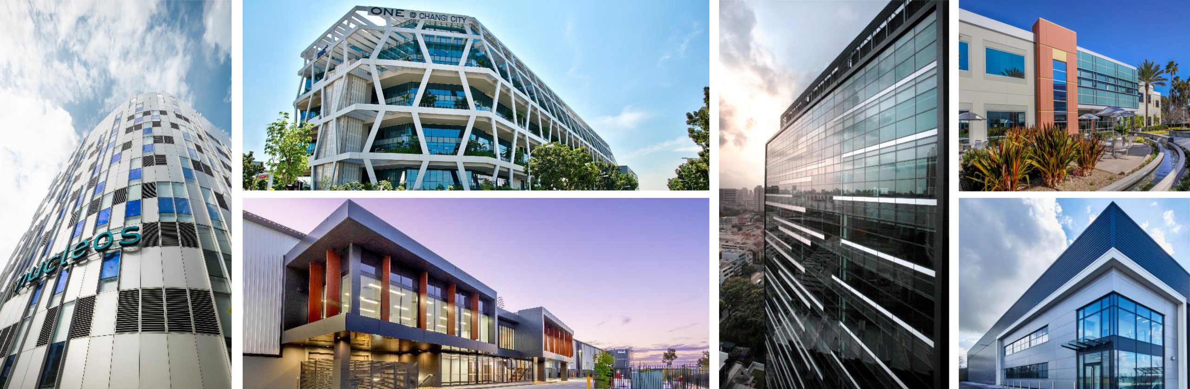

**Thank you**

